Phospho sulfonic acid catalyzed synthesis of benzimidazole, benzoxazole and quinoxaline derivatives under green solvent at ambient temperature
Parisa Shirkhani^{a,}*, Hamed Seifournia^{b}, Ehsan Mirzajanzadeh^{b}, Marzieh Rekavandi^{b}, Marziyeh Sarayloo^{b}, Saeid Afshari Sharif Abad^{b}, Zahra Malkeshi^{b}, Sakineh Rostamian Tuyehdarvaryª
ª Department of Chemistry, Faculty of Science, Ilam University, P.O. Box 69315516, Ilam, Iran
^{b} Chemistry Department, Qaemshahr Branch, Islamic Azad University, P.O. Box 163, Qaemshahr, Iran

Data spectral of all new products

2-Phenyl-1H-benzo[d]imidazole (Entry 1)
¹H NMR (300 MHz, DMSO-d₆): δ (ppm) 12.87 (broad s, 1H), 8.20-8.16 (m, 2H), 7.60-7.46 (m, 5H), 7.23-7.18 (m, 2H). ¹³C NMR (75 MHz, DMSO-d₆): δ (ppm) 116.0, 124.0, 127.9, 130.2, 131.1, 131.5, 140.3, 153.5.
2-(p-Tolyl)-1H-benzo[d]imidazole (Entry 2)
¹H NMR (300 MHz, DMSO-d6): δ (ppm) 12.79 (s, 1H, -NH), 8.05-8.08 (d, J = 10.2 Hz, 2H), 7.56-7.59 (m, 2H), 7.34-7.36 (d, J = 10.2 Hz, 2H), 7.17-7.21 (m, 2H), 2.37 (s, 3H). ¹³C NMR (75 MHz, DMSO-d₆): δ (ppm) δ 20.9, 114.9, 121.9, 126.3, 127.4, 129.4, 139.5, 151.3.
2-(4-Methoxyphenyl)-1H-benzo[d]imidazole (Entry 3)
¹H NMR (300 MHz, CD₃OD): δ (ppm) 7.99-8.02 (m, 2H), 7.54-7.57 (m, 2H), 7.20-7.22 (m, 2H), 7.03-7.08 (m, 2H), 3.83 (s, 3H). ¹³C NMR (75 MHz, CD₃OD): δ (ppm) δ 56.0, 115.6, 123.5, 123.7, 129.5, 153.6, 163.0.
2-(4-Chlorophenyl)-1H-benzo[d]imidazole (Entry 5)
¹H NMR (300 MHz, DMSO-d₆): δ (ppm) 13.13 (broad s, 1H), 8.23 (d, J = 8.5 Hz, 2H), 7.64-7.58 (m, 2H), 7.34-7.18 (m, 4H). ¹³C NMR (75 MHz, DMSO-d₆): δ (ppm) 115.8, 115.9, 124.2, 129.3, 129.7, 130.3, 137.3, 152.1.
2-Phenylbenzo[d]oxazole (Entry 11)
¹H NMR (300 MHz, CDCl₃): δ (ppm) 8.21-8.27 (m, 2H), 7.75-7.79 (m, 1H), 7.48-7.58 (m, 4H), 7.31-7.36 (m, 2H). ¹³C NMR (75 MHz, CDCl₃) δ 110.8, 120.2, 124.7, 125.3, 127.3, 127.8, 129.1, 131.7, 142.3, 150.9, 163.2.

¹H NMR spectrum of 2-(p-Tolyl)-1H-benzo[d]imidazole (Entry 2)
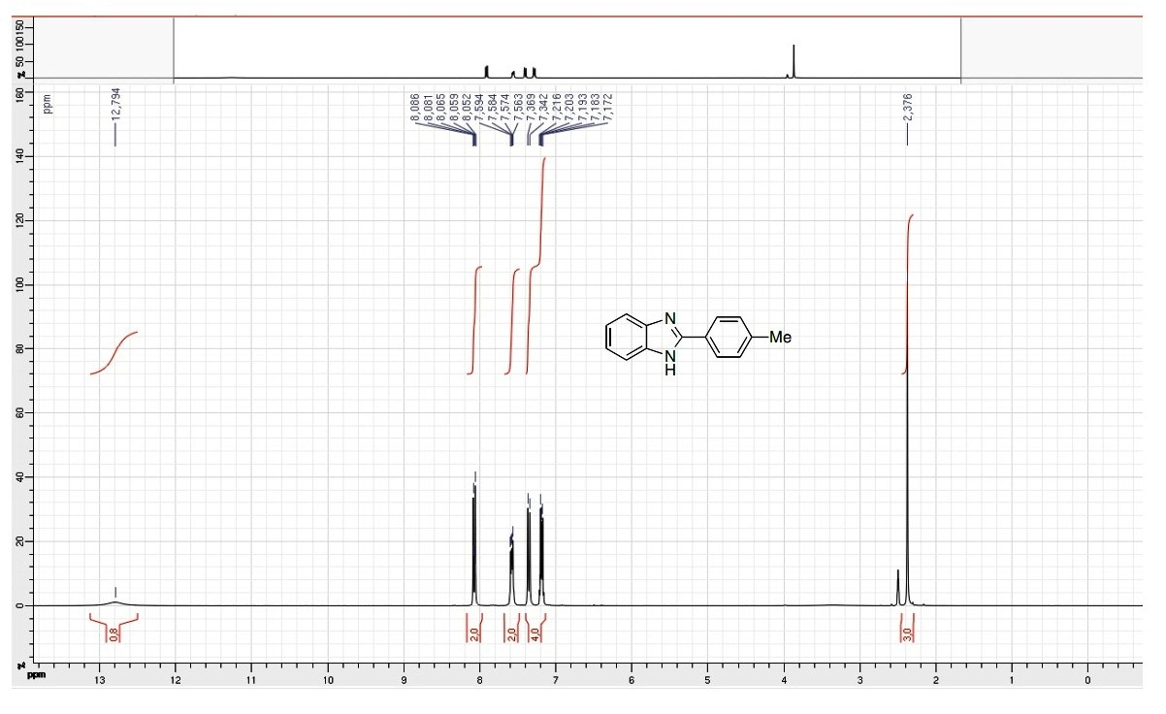

¹³C NMR spectrum of 2-(p-Tolyl)-1H-benzo[d]imidazole (Entry 2)
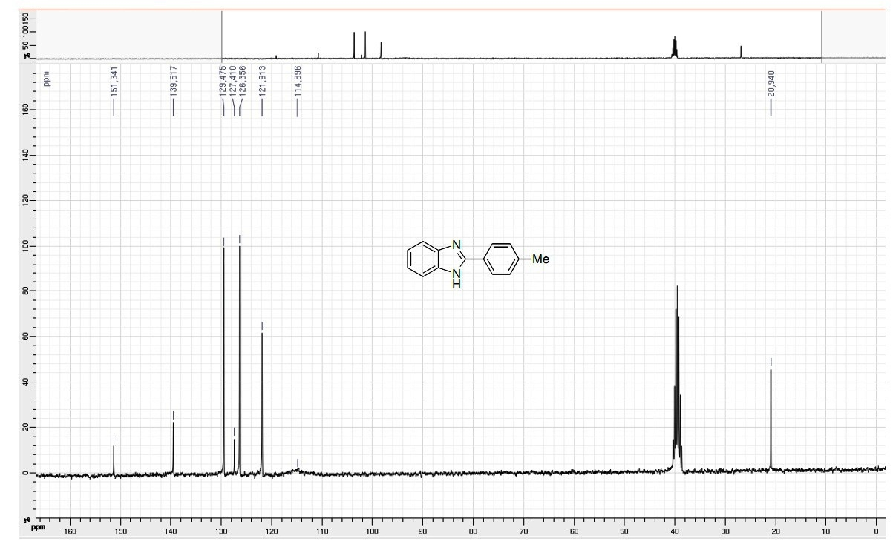

¹H NMR spectrum of 2-(4-Chlorophenyl)-1H-benzo[d]imidazole (Entry 5)
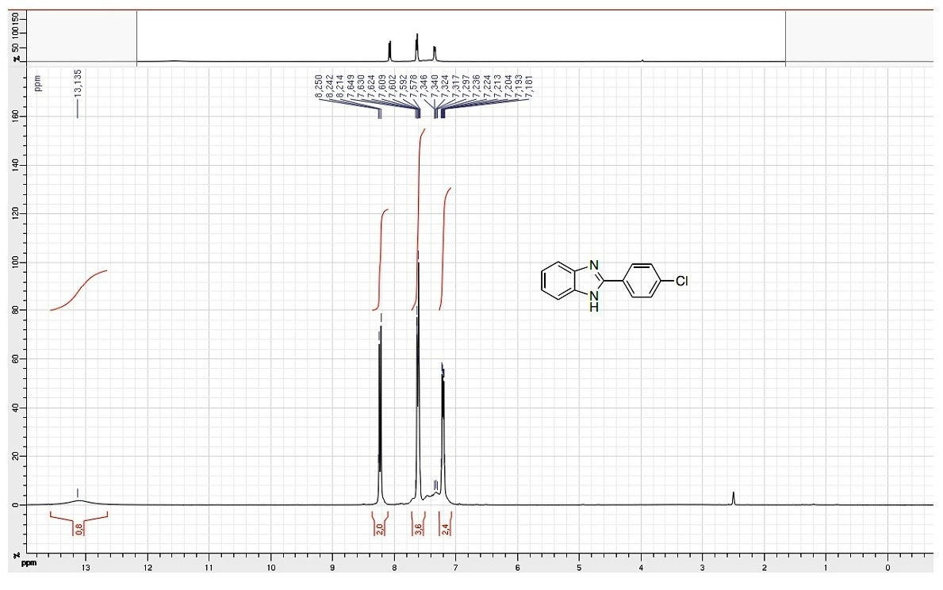

¹³C NMR spectrum of 2-(4-Chlorophenyl)-1H-benzo[d]imidazole (Entry 5)

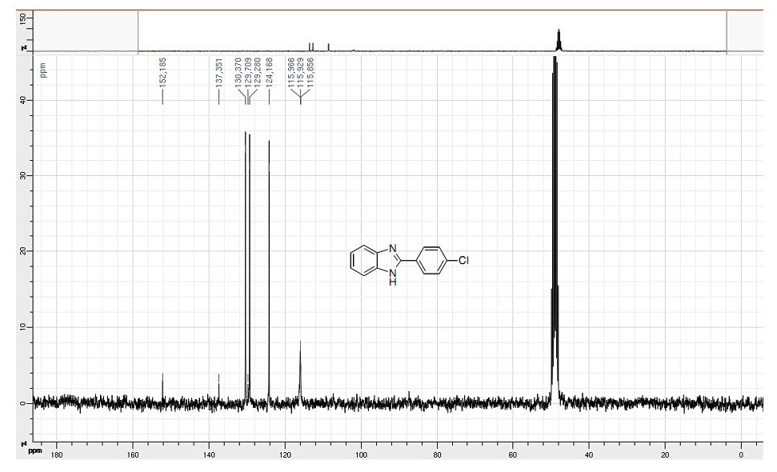

¹H NMR spectrum of 2-Phenylbenzo[d]oxazole (Entry 11)

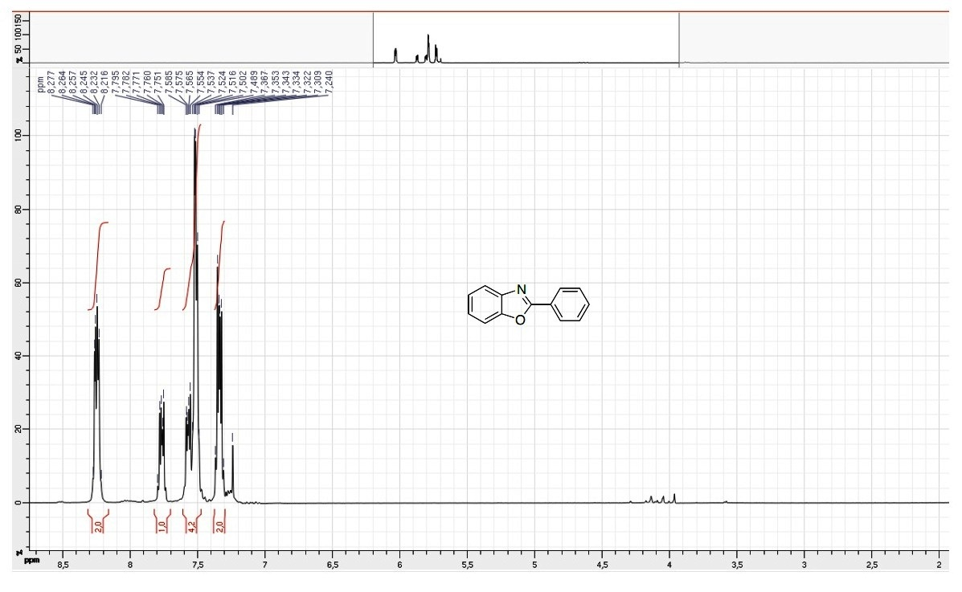

¹³C NMR spectrum of 2-Phenylbenzo[d]oxazole (Entry 11)

