Synergy of binary ionic liquids in a three component one pot synthesis of 3,4,6-triarylpyridazine at ambient temperature.

Pranab J.Das*, Dimpee Das
Department of Chemistry, Gauhati University , Guwahati -781014, India
*Corresponding Author Email: pranabjdas52@gmail.com

( Supporting informations)
Preparation and characterization of pyridinium based ionic liquids
1-n-octyl-3,5-dimethyl pyridinium bromide:

0.1 mol of 3,5-dimethyl pyridine (lutidine) and 0.1 mol of octyl bromide were mixed and stirred for 20 hours in the dark. A pale yellow coloured solid precipitated on completion of the reaction. Complete conversion to product
was observed. The recovered product was found to be pure and further purification was unnecessary. The IL obtained was stored in a desiccator.

Molecular formula: | C₁₅H₂₄BrN.
Nature: | Pale yellow solid.
Melting Point: | 54.70 °C.
¹H NMR (300 MH_{Z}, CDCl₃, Me₄Si) (δ_{H} ppm) : | 9.134, 9.102 (2H, CH pyr ), 7.989(1H, CH pyr),2.376-2.804(6H, CH₃), 1.230-2.165(14 H CH₂), 0.851(3H ,CH₃)
¹³C NMR (75 MHz, CDCl₃) (δ ppm): | 146.01, 141.73, 138.77, 61.64, 31.92 , 31.62, 30.90, 28.94, 26.05, 22.52, 18.52, 14.01
MS (ES+): m/z | 218.3596 .
The thermal decomposition point | 491 K

1-n-butyl -3,5-dimethyl pyridinium bromide:

0.1 mol of 3,5-dimethyl pyridine (lutidine) and 0.1 mol of n-butyl bromide were mixed and stirred for 24 hours in the dark. Precipitation of a pale yellow coloured solid product indicated the completion of the reaction. Complete conversion of the reactants was observed.
The IL obtained was found to be almost pure and no further purification was necessary. The IL was stored in a desiccator for further use.

Molecular formula: | C₁₁H₁₈BrN.
Nature: | Pale yellow solid.
Melting Point: | 97.28 °C.
¹H NMR (300 MH_{Z}, CDCl₃, Me₄Si) (δ_{H} ppm): | 9.374, 9.352 (2H, CH pyr), 7.850 ( 1H, CH pyr) 4.836 (6H,CH₃), 1.282-2.577 (6H,CH₂), 0.877 (3H,CH₃)
¹³C NMR (75 MHz, CDCl₃) (δ ppm): | 158.51, 144.17, 128.70, 60.59, 33.51, 22.08, 19.09, 13.36.
HRMS (+ESI): m/z | 164.2610
The thermal decomposition point | 498 K.

Characterization of ionic liquids

Thermogravimetric analysis (TGA)
TGA experiments were performed using a TGA-DSC1, Mettler Toledo instrument. The samples were weighed and placed in a platinum crucible. They were then heated in a stream of nitrogen atmosphere, from room temperature to 700 °C with a heating rate usually of 10 °C /min.
Differential scanning calorimetry (DSC)
The calorimetric measurements were performed with a Perkin Elmer DSC4000 system. N₂ gas with a flow rate of 20 mL/min was purged through the sample and heated with heating rate of 10 °C /min.
Results
TGA: The thermogravimetric analysis curves of three secondary amine based ILs and three pyridinium based ILs are shown in Figure 1 and figure 2 respectively. In case of pyridinium based IL, the thermal stability is seen to vary with the nature of the cation which is found to the highest in case of 1-n-butyl-3,5-dimethyl pyridinium cation. The thermal stability increases in the following sequence of the ILs, 1-n-octyl-3,5-dimethyl pyridinium bromide < 1-butyl-3,5-dimethyl pyridinium bromide. The TGA thermograms are shown

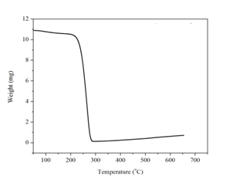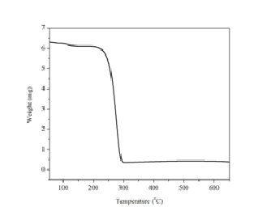
Figure 1 : TGA curve of [ 1-n-O-3,5-diMPyrBr] Figure 2: TGA curve of [ 1-n-B-3,5-diMPyrBr]

DSC: The melting point of these ILs has been studied by differential scanning calorimetry. The first endothermic peak of the thermogram represents the melting point of the ILs. Results showed that 1-n-butyl-3,5-dimethyl pyridinium bromide has melting point of 97.28 °C but 1-n-octyl-4-methyl pyridinium bromide has lower melting point which is 54.70 °C.

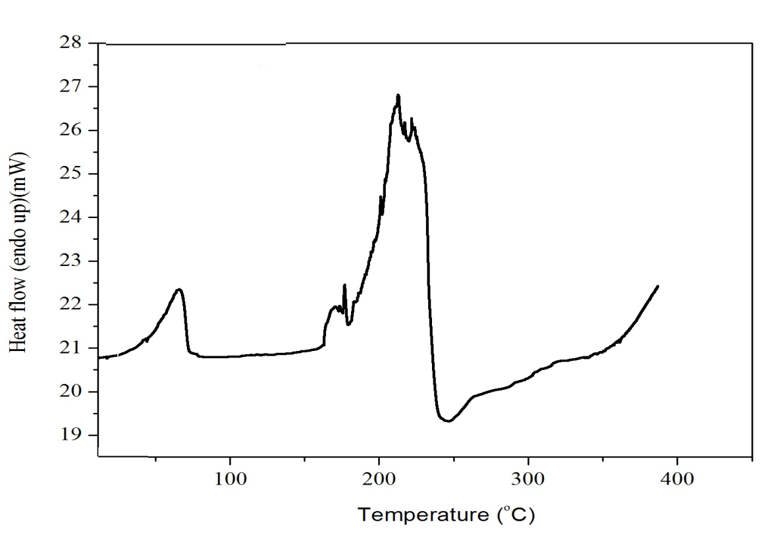
Fig:- DSC of 1-n-octyl-3,5-dimethylpyridinium bromide

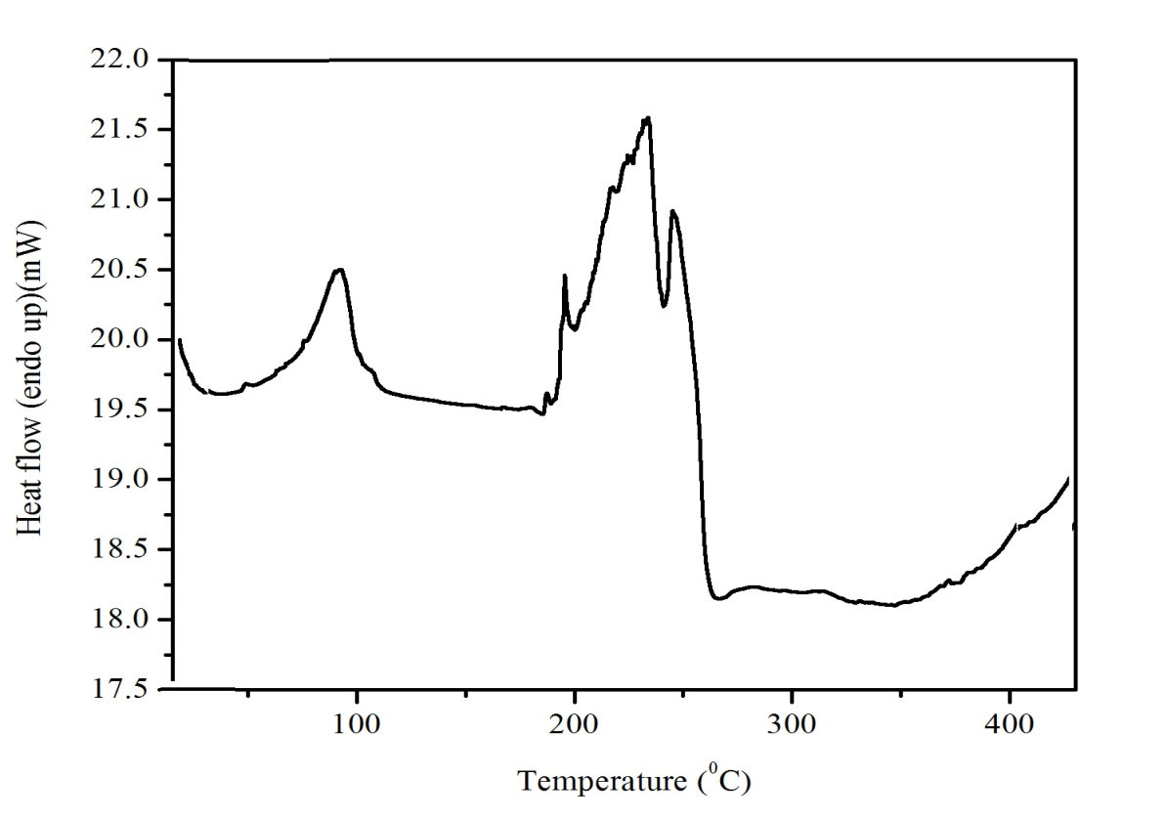
Fig:- DSC of 1-n-butyl-3,5-dimethylpyridinium bromide

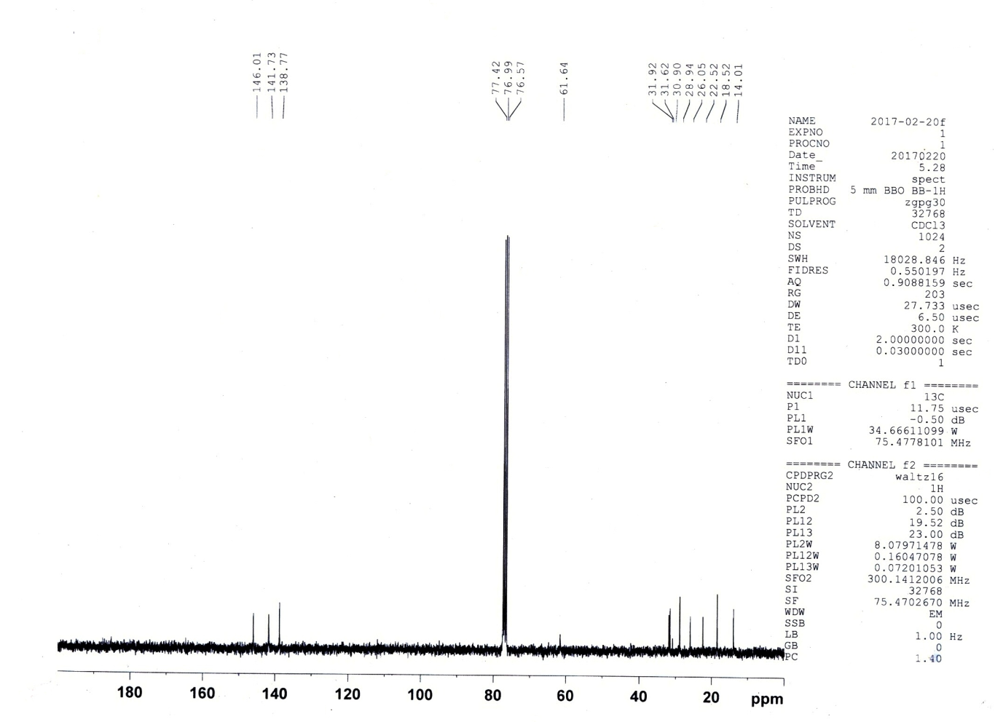

¹³C NMR spectra of 1-n-octyl-3,5-dimethyl pyridinium bromide
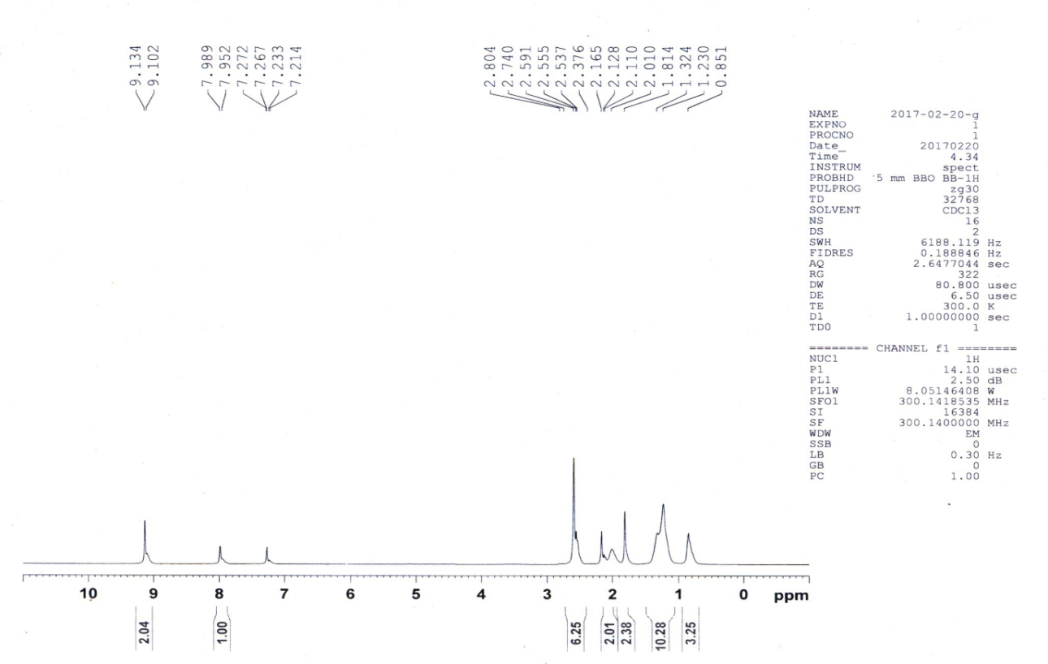

¹H NMR of 1-n-butyl-3,5-dimethylpyridinium bromide

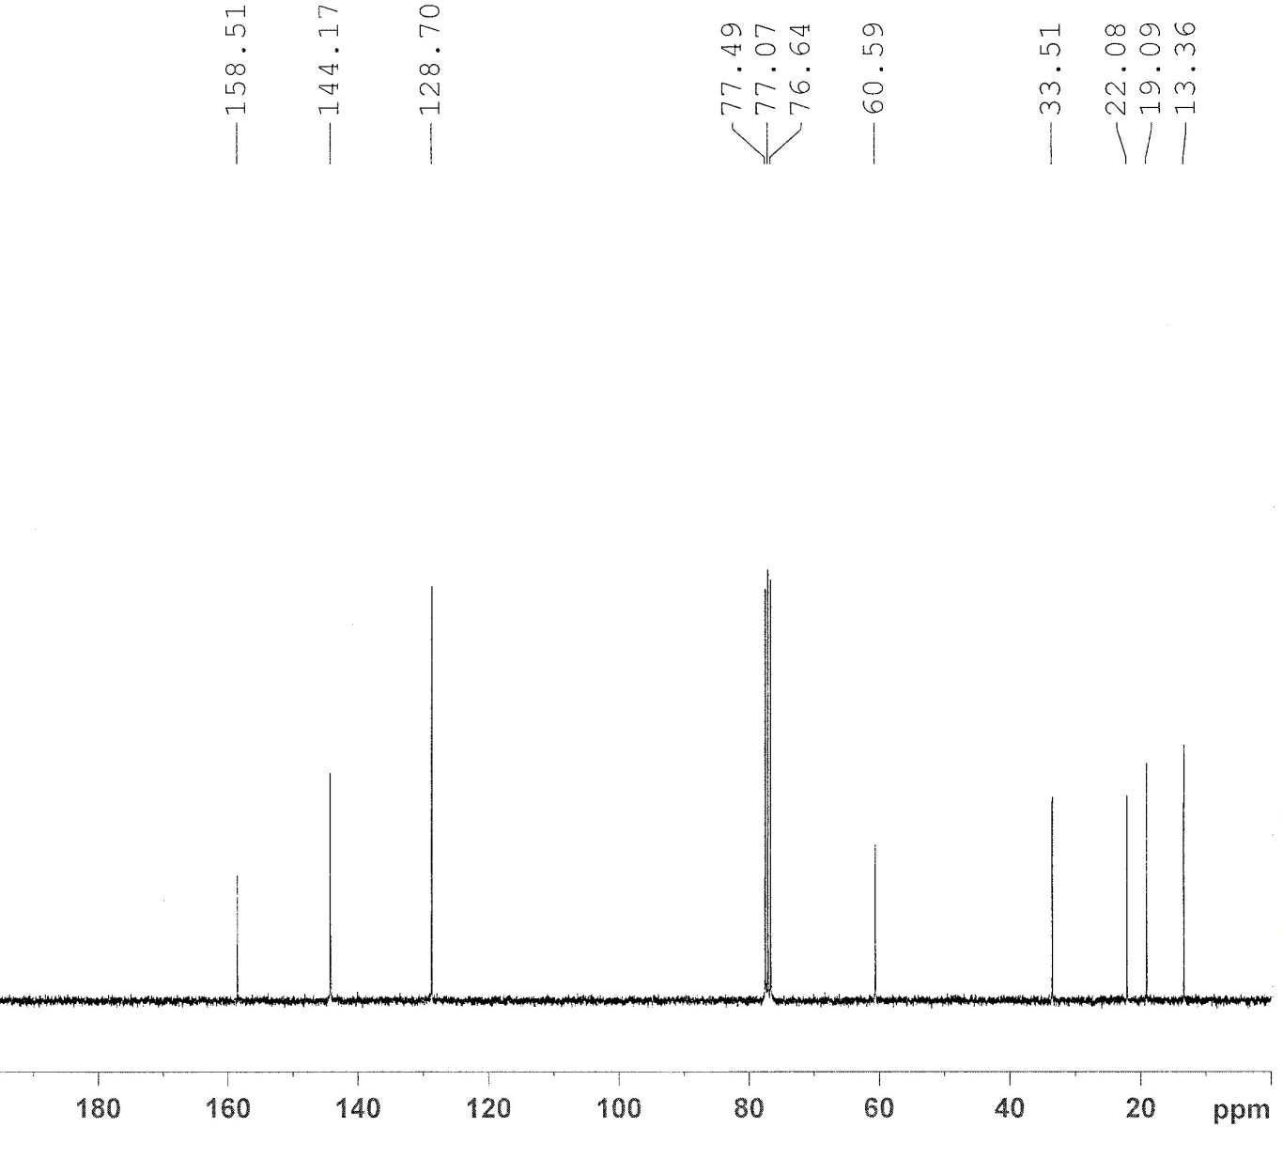

¹³C NMR spectra of 1-n-butyl-3,5-dimethylpyridinium bromide

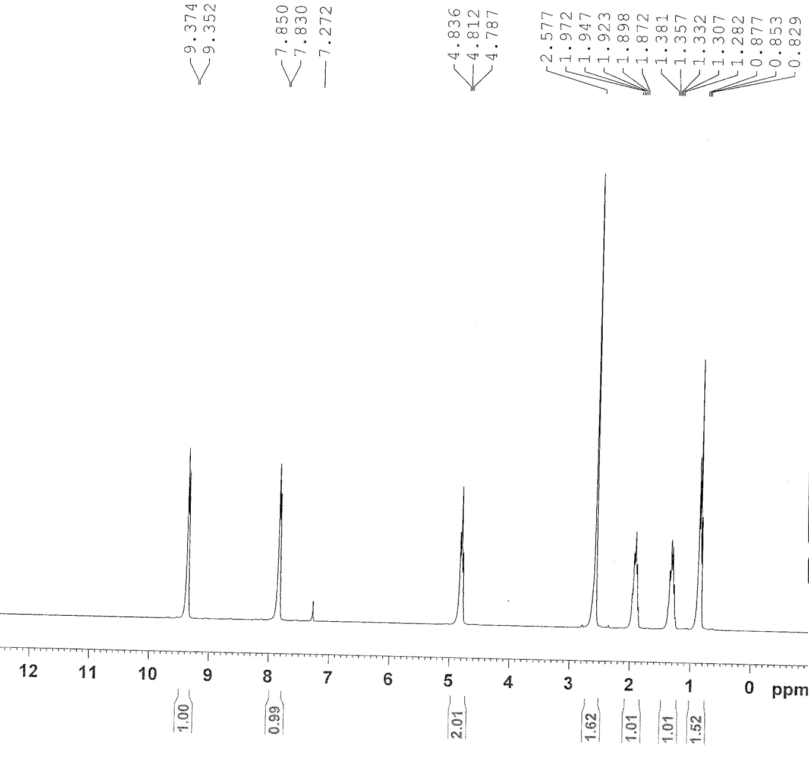
¹H NMR Spectra of 1-n-butyl-3,5-dimethylpyridinium bromide

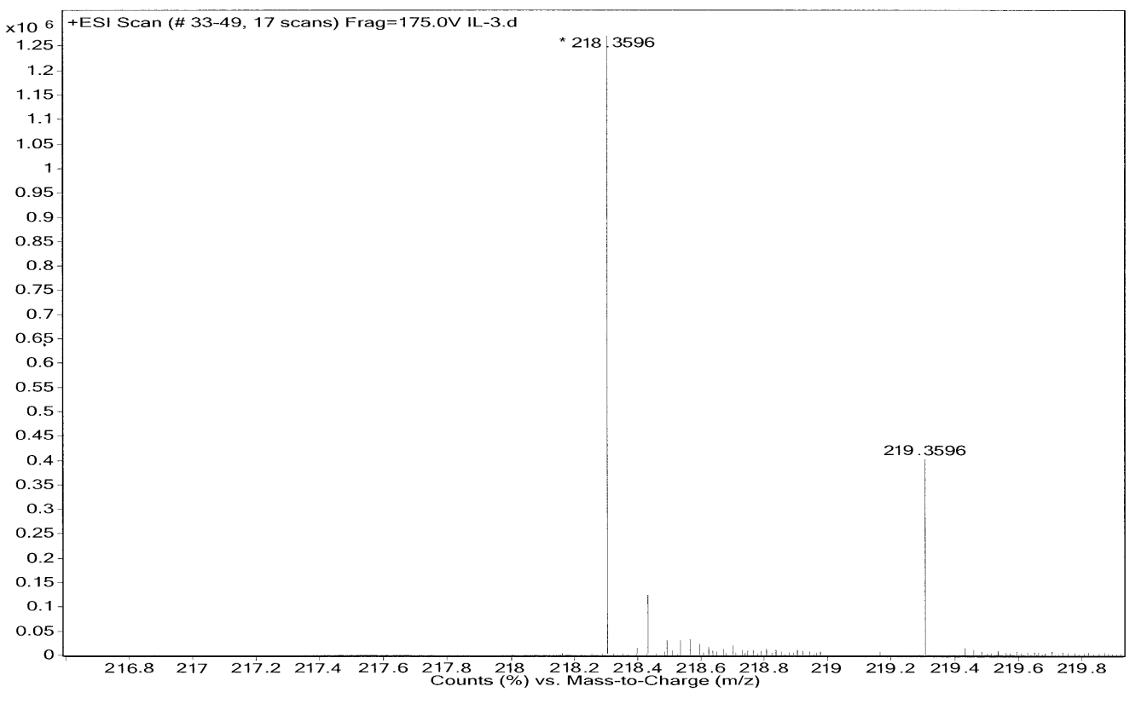
HRMS of 1-n-octyl-3,5-dimethylpyridinium bromide

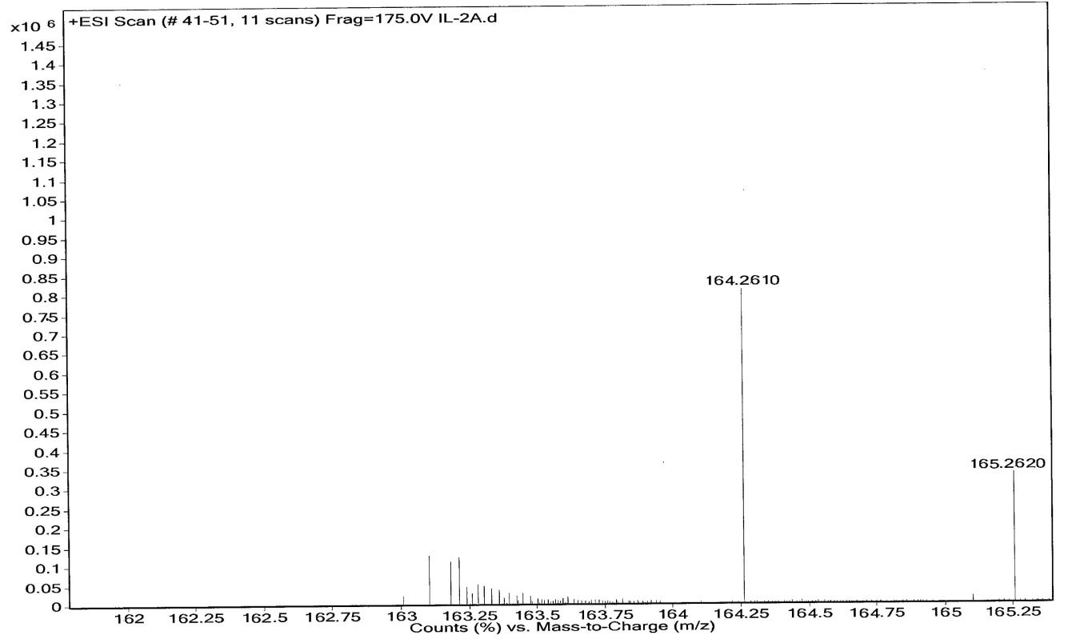
HRMS of 1-n-butyl-3,5-dimethylpyridinium bromide

Spectra of entry 1, (3,4,6-triphenylpyridazine):

- Mass spectra

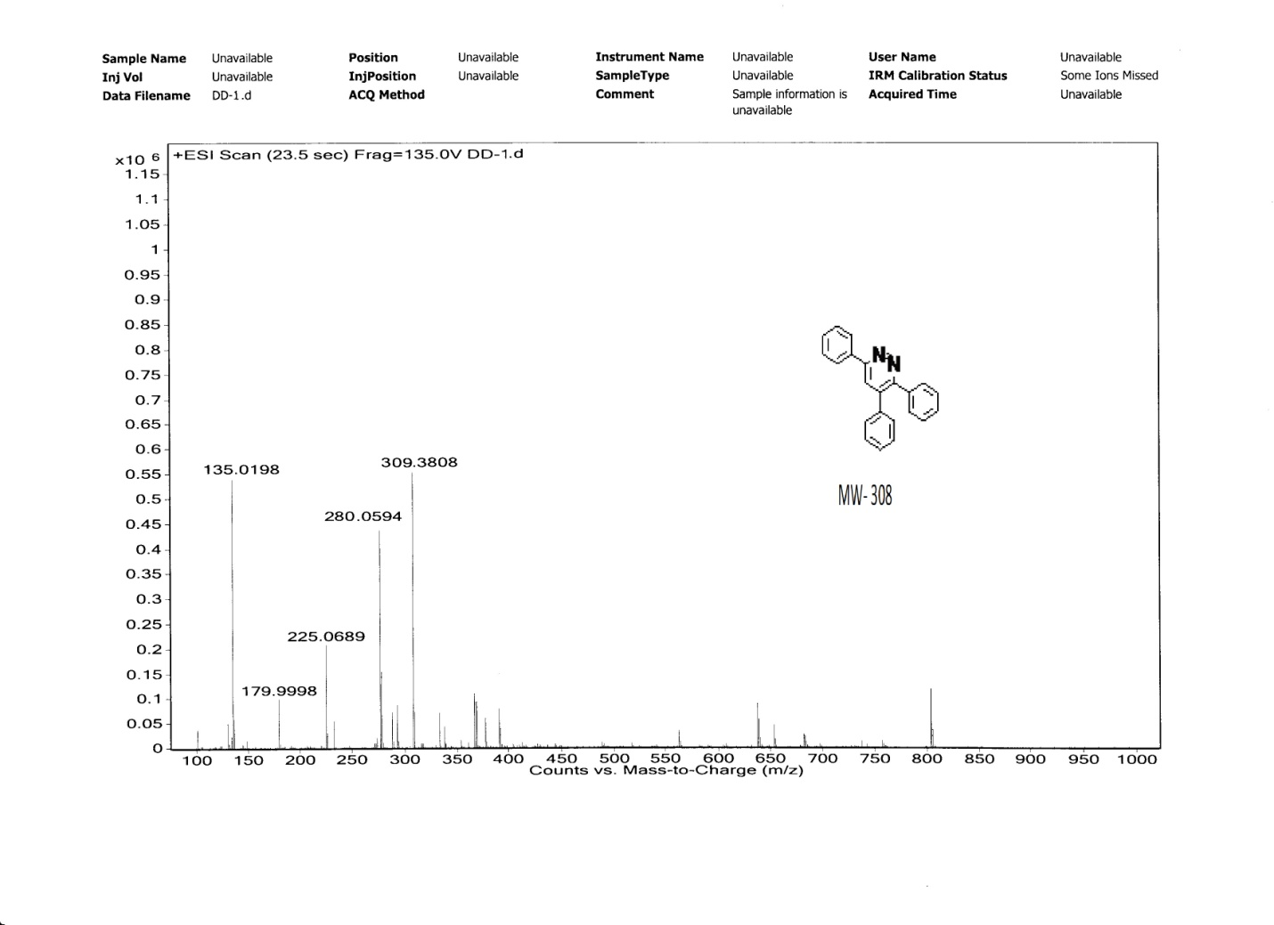

¹H NMR Spectra of entry 1, (3,4,6-triphenylpyridazine):

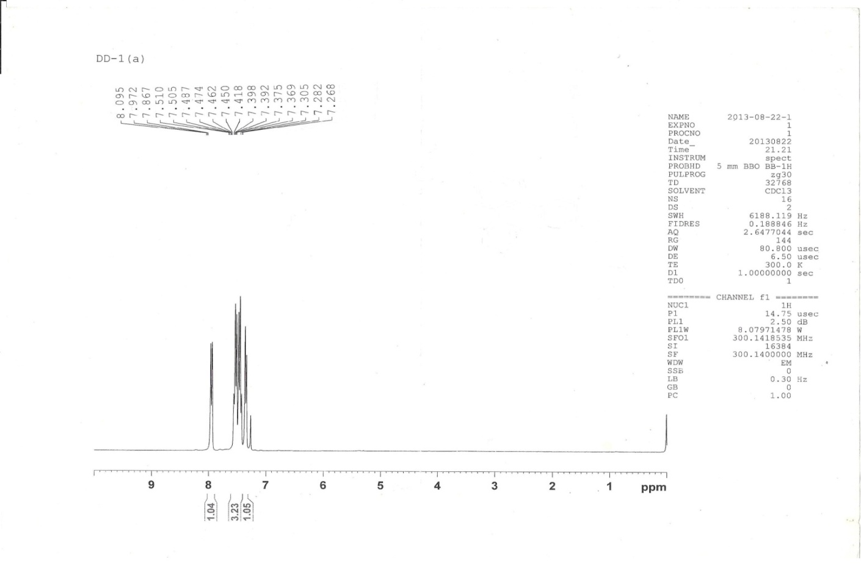

¹³C –NMR spectra ( CDCl₃ 75 MHz, TMS as internal standard ) of Entry 1 ((3,4,6-triphenylpyridazine):
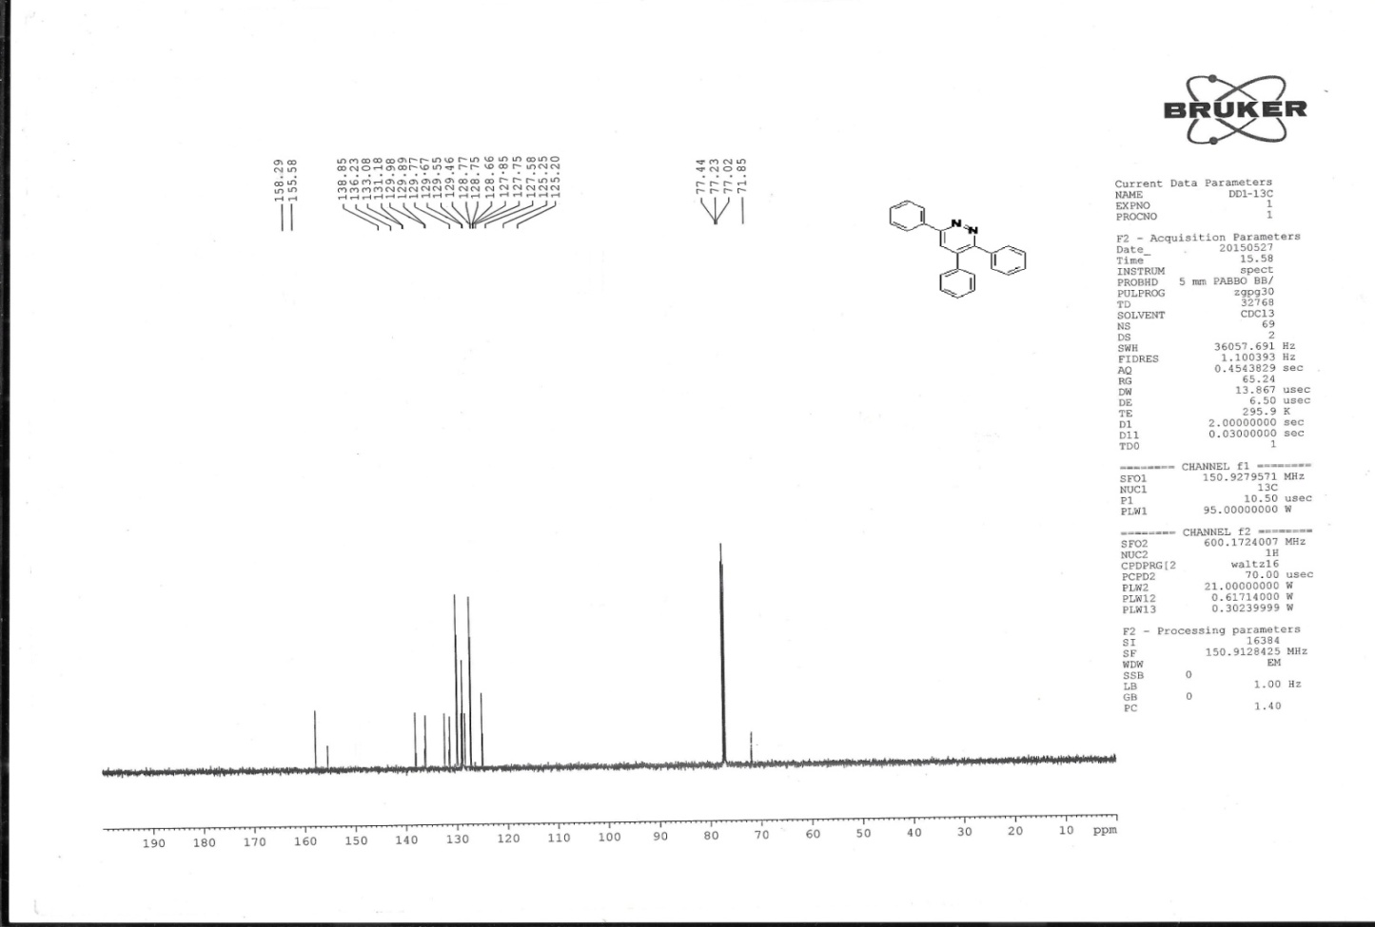

HRMS of Entry 3 [3,4-diphenyl-6-(4-chlorophenyl)pyridazine ]
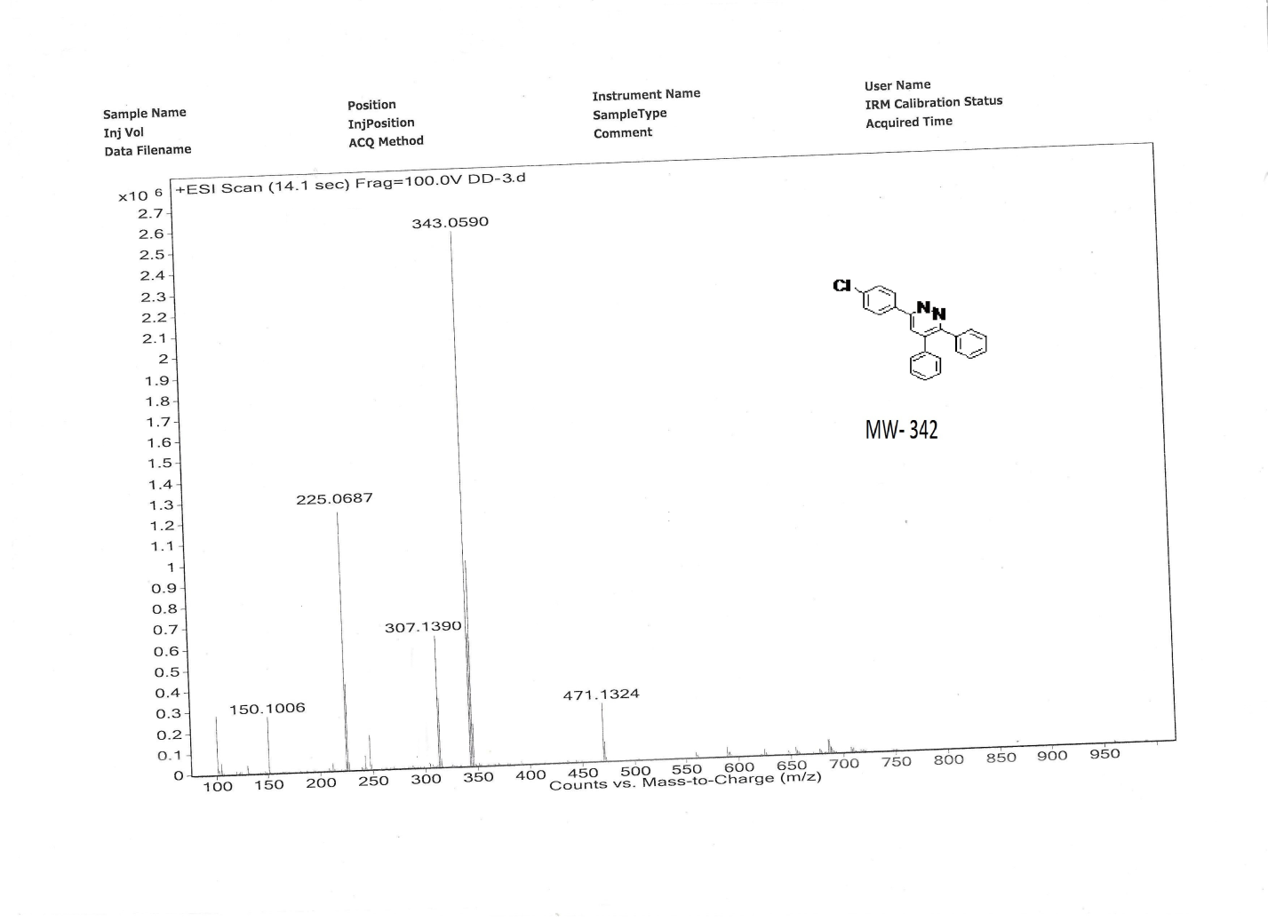

¹H NMR spectra of entry 3 [3,4-diphenyl-6-(4-chlorophenyl)pyridazine ]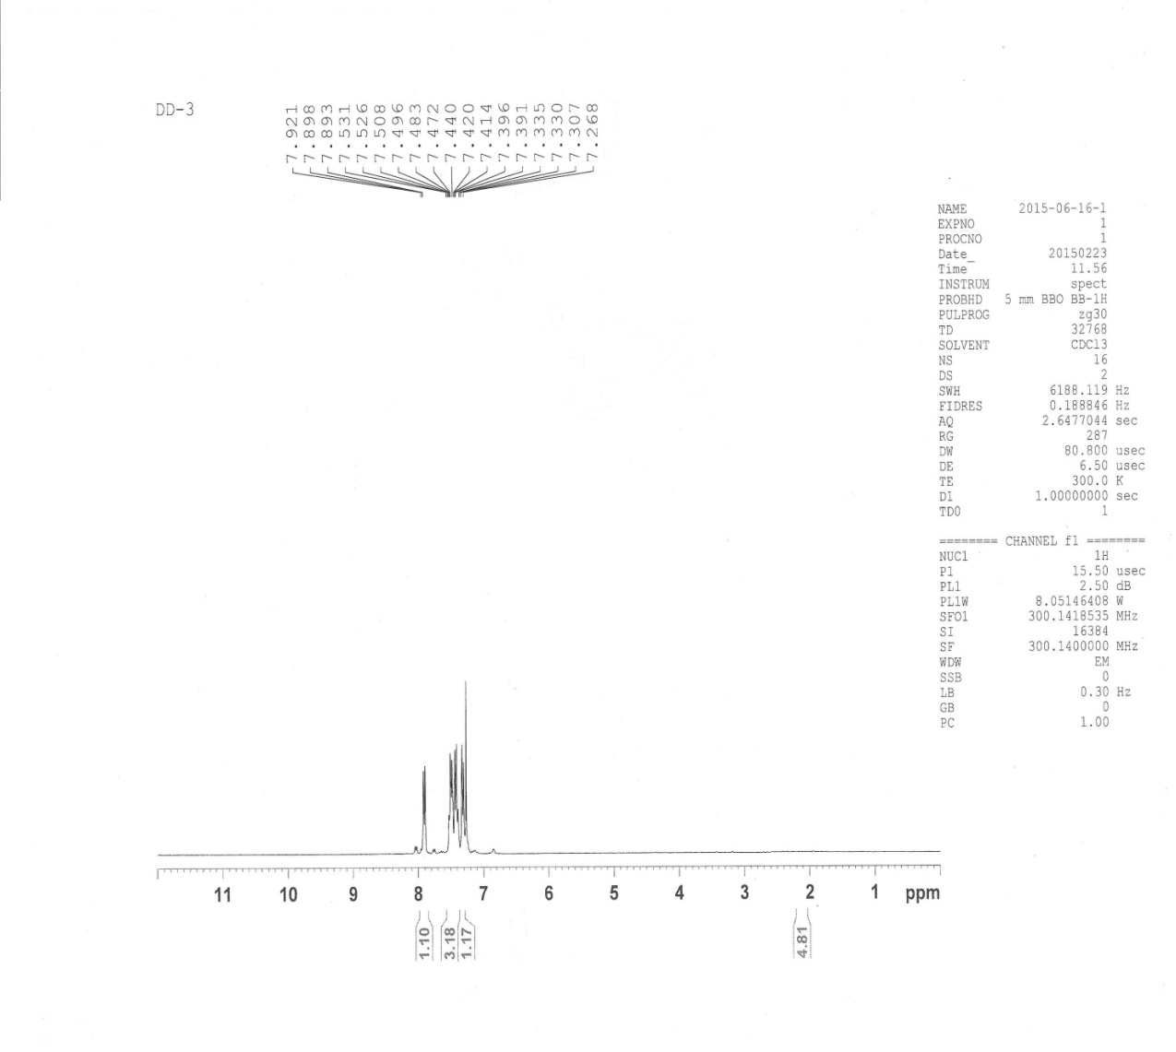

¹³C NMR ( 75 MHz, CDCl₃) Entry 3 [3,4-diphenyl-6-(4-chlorophenyl)pyridazine ]

¹H NMR spectra of entry 4 [ 3,4-diphenyl-(4-methoxyphenyl)pyridazine]

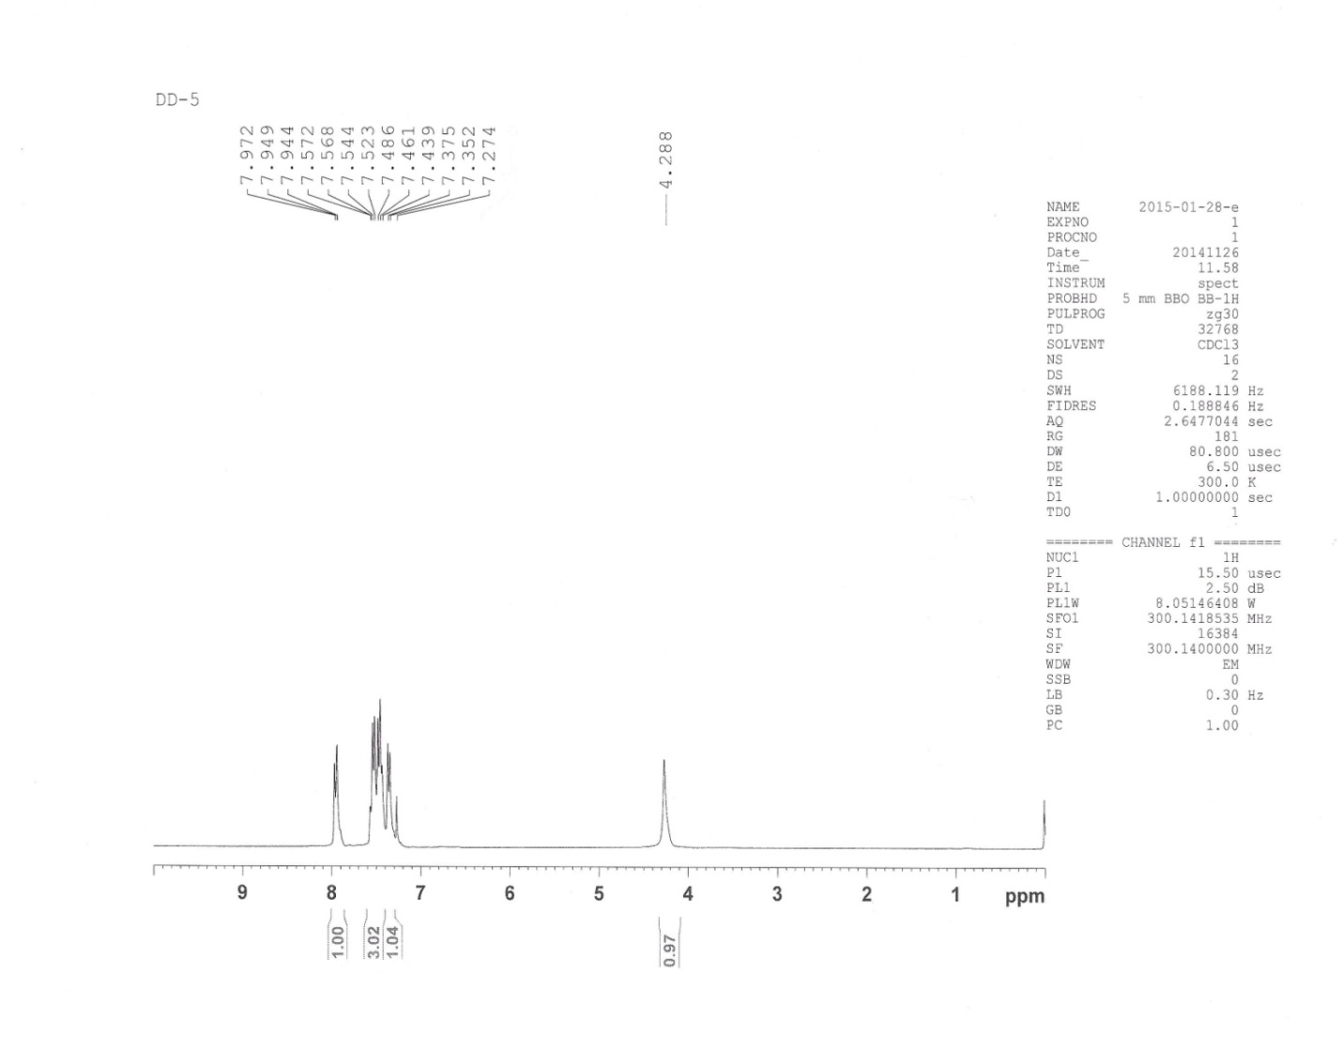

ENTRY 4: ¹³C-NMR (75 MHz, CDCl₃ of 3,4-diphenyl-6-(4-methoxyphenyl)pyridazine
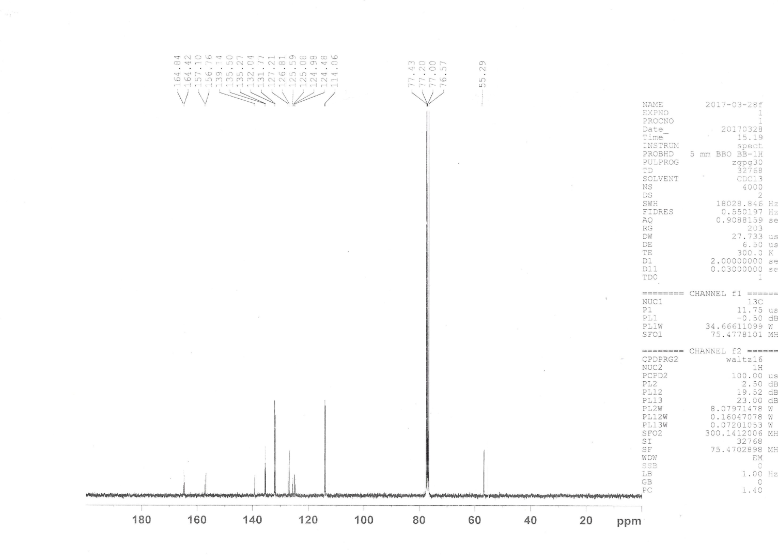

HRMS of entry 4 [3,4-diphenyl-(4-methoxyphenyl)pyridazine]

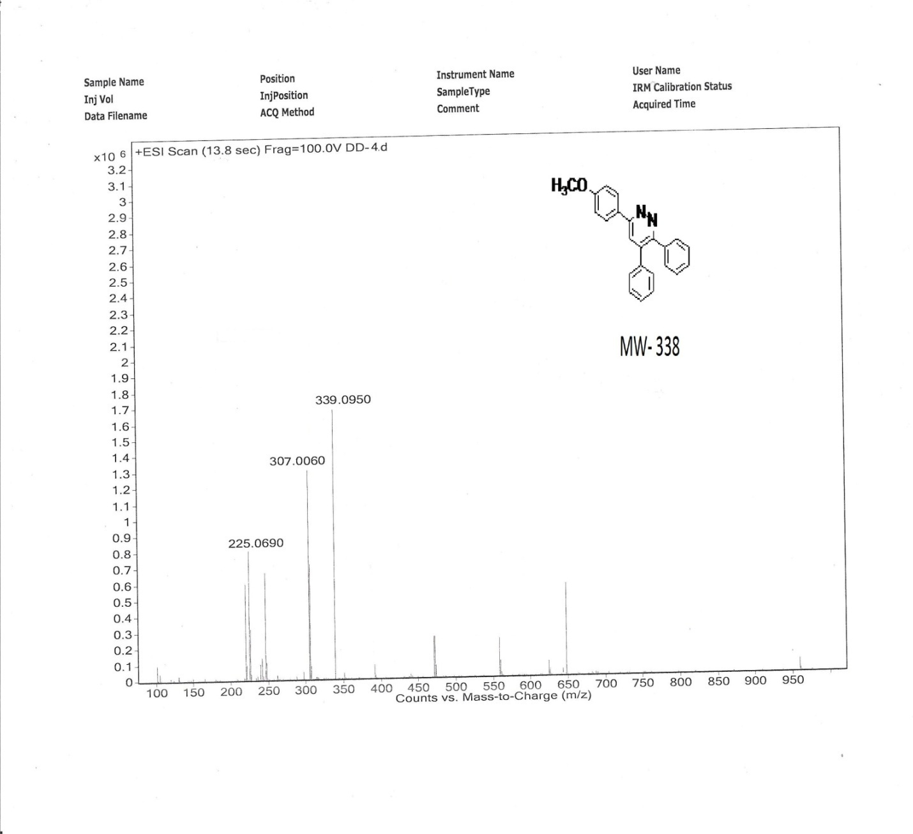

HRMS of entry 5 [ 3,4-diphenyl-(4-bromophenyl)pyridazine]

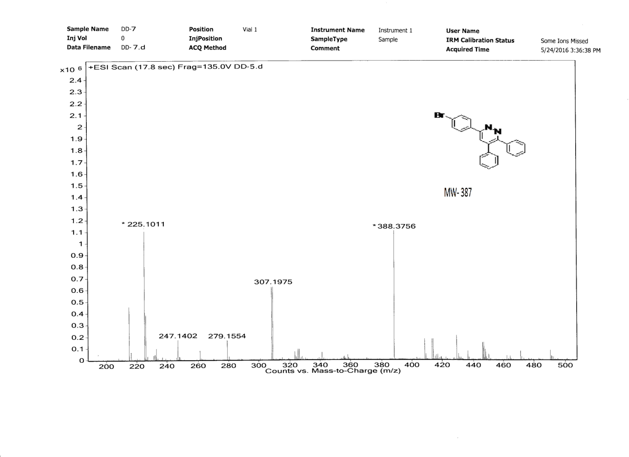

¹H NMR of entry 5 [ 3,4-diphenyl-(4-bromophenyl)pyridazine]
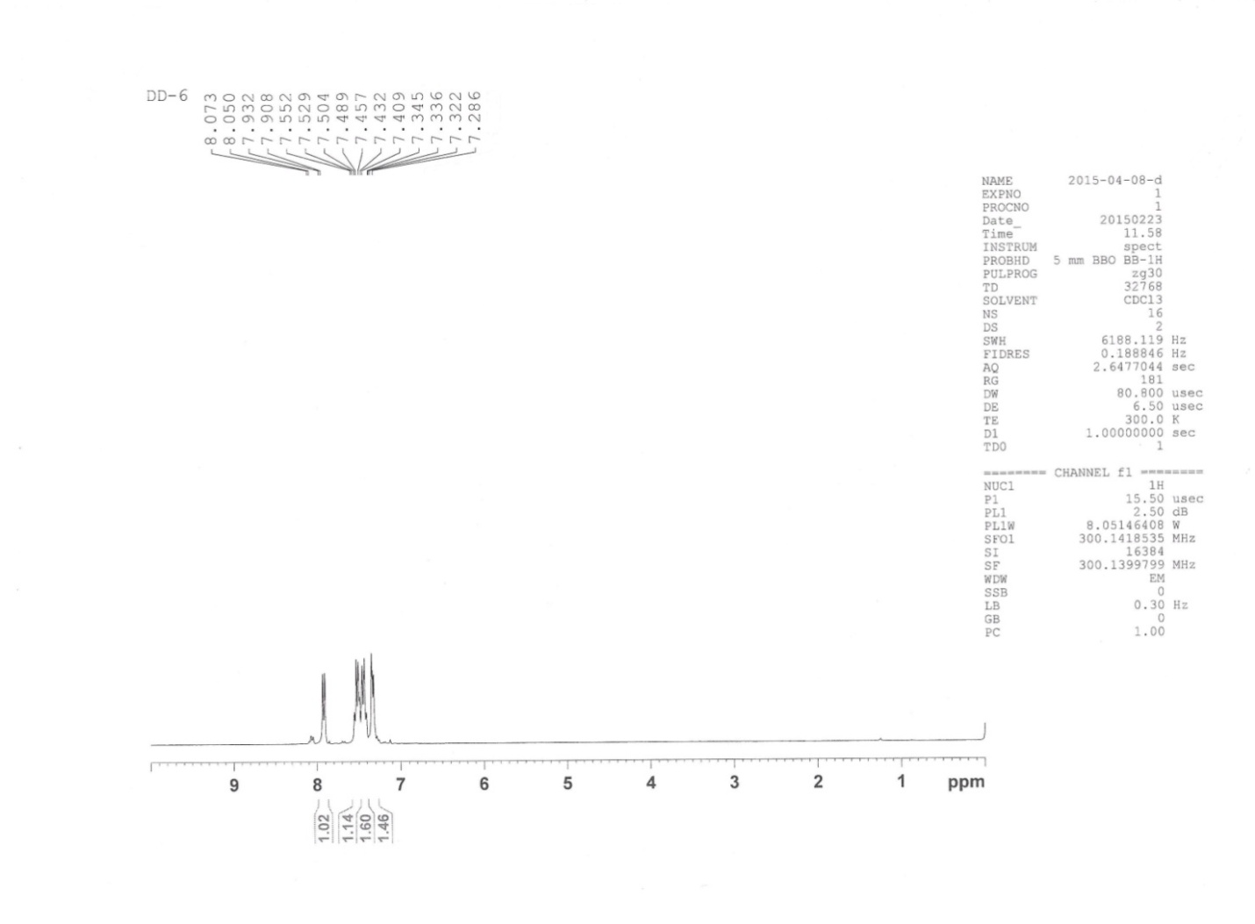

¹³C NMR of entry 5 [ 3,4-diphenyl-(4-bromophenyl)pyridazine]
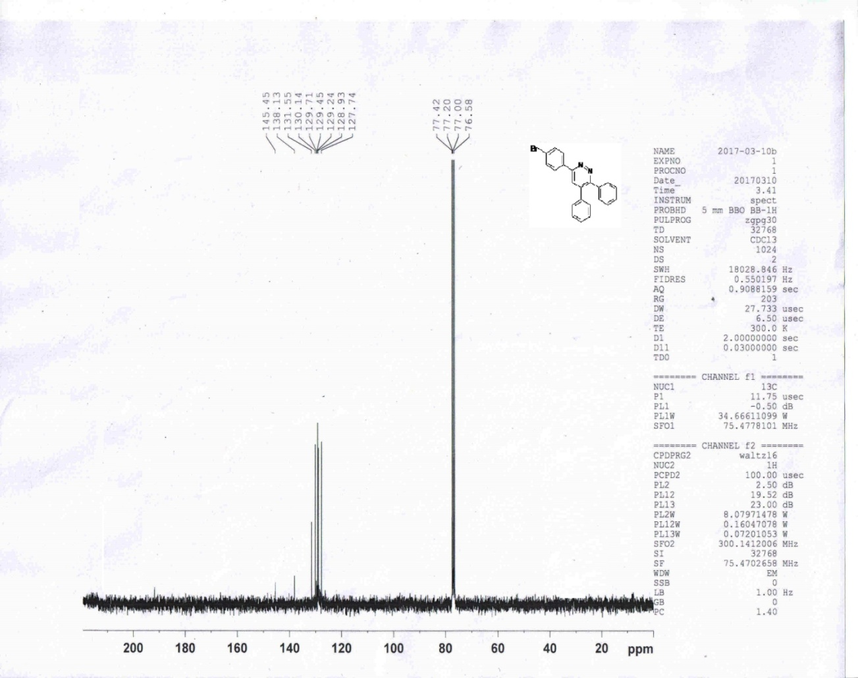

¹H NMR of Entry 6 [3,4-diphenyl-6-(4-hydroxyphenyl)pyridazine]

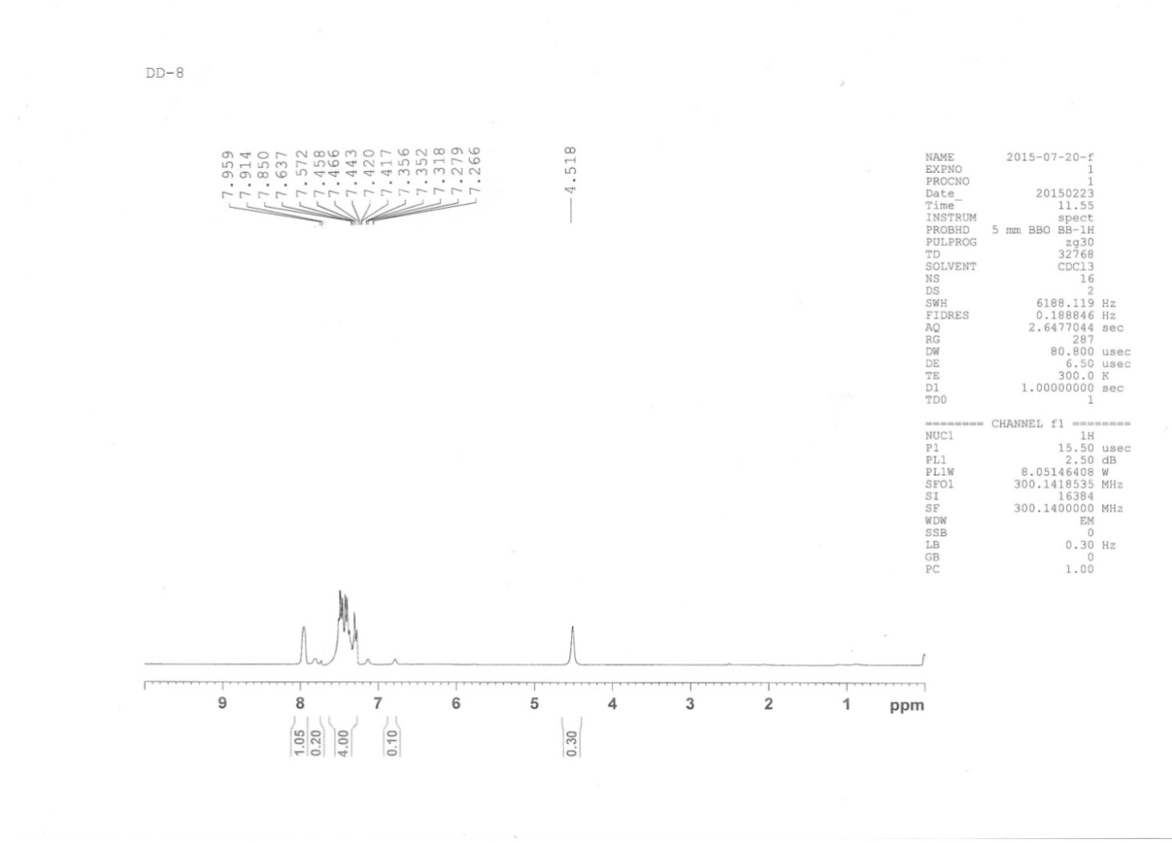

¹³C of entry6 [3,4-diphenyl-6-(4-hydroxyphenyl)pyridazine]

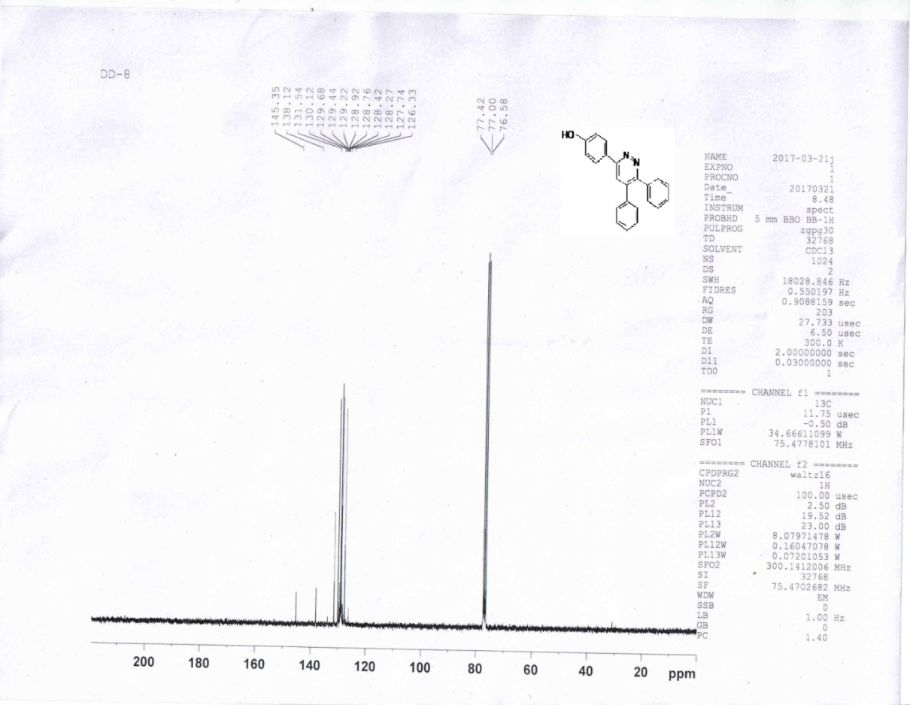

¹H –NMR of entry6 [3,4-diphenyl-6-(4-hydroxyphenyl)pyridazine]

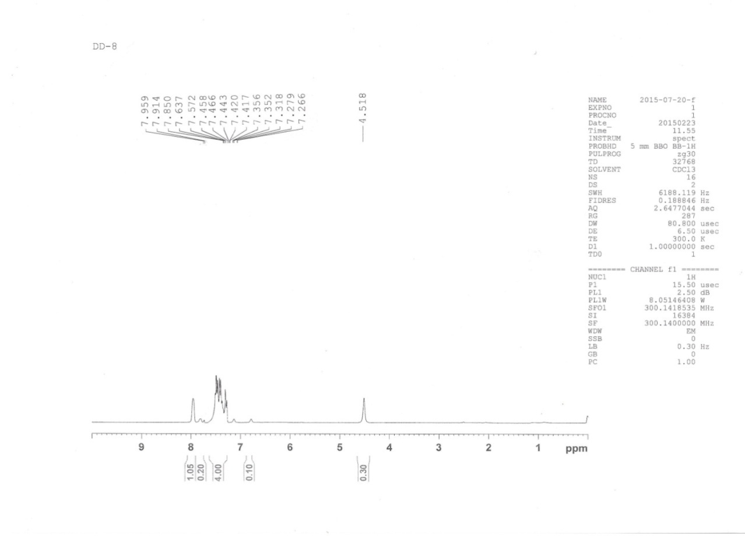

¹H –NMR of entry7 [3,4-diphenyl-6-(p-nitrophenyl)pyridazine]
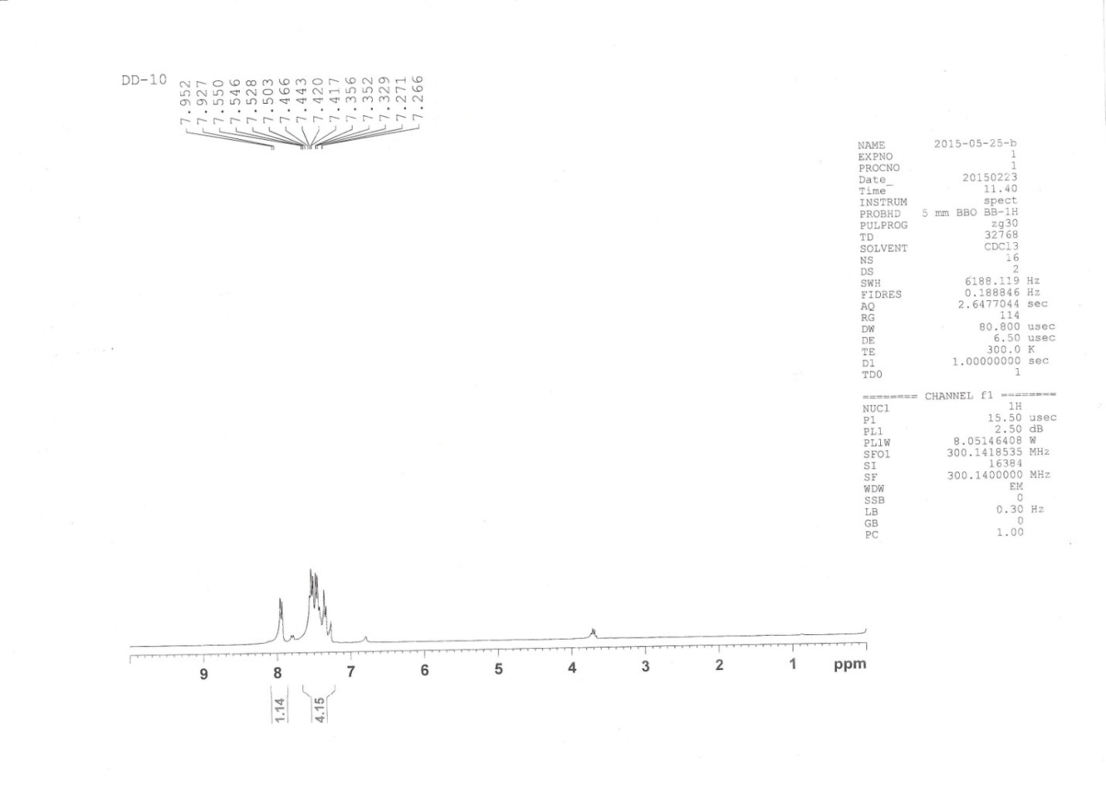

ENTRY 7: ¹³C-NMR (75 MHz, CDCl₃), 3,4-diphenyl-6-(4-nitrophenyl)pyridazine

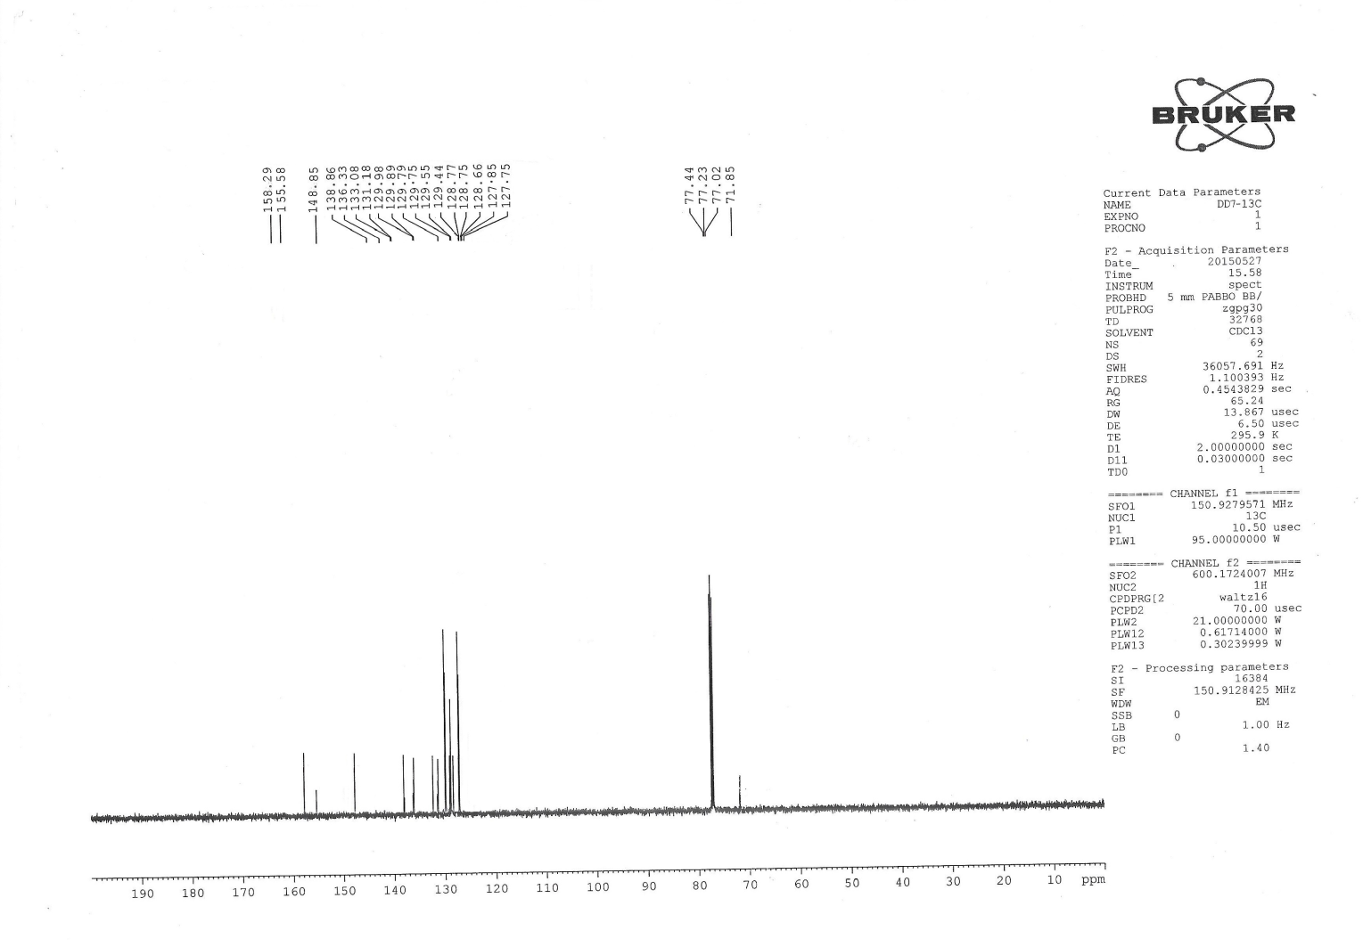

HRMS of entry7 [3,4-diphenyl-6-(p-nitrophenyl)pyridazine]

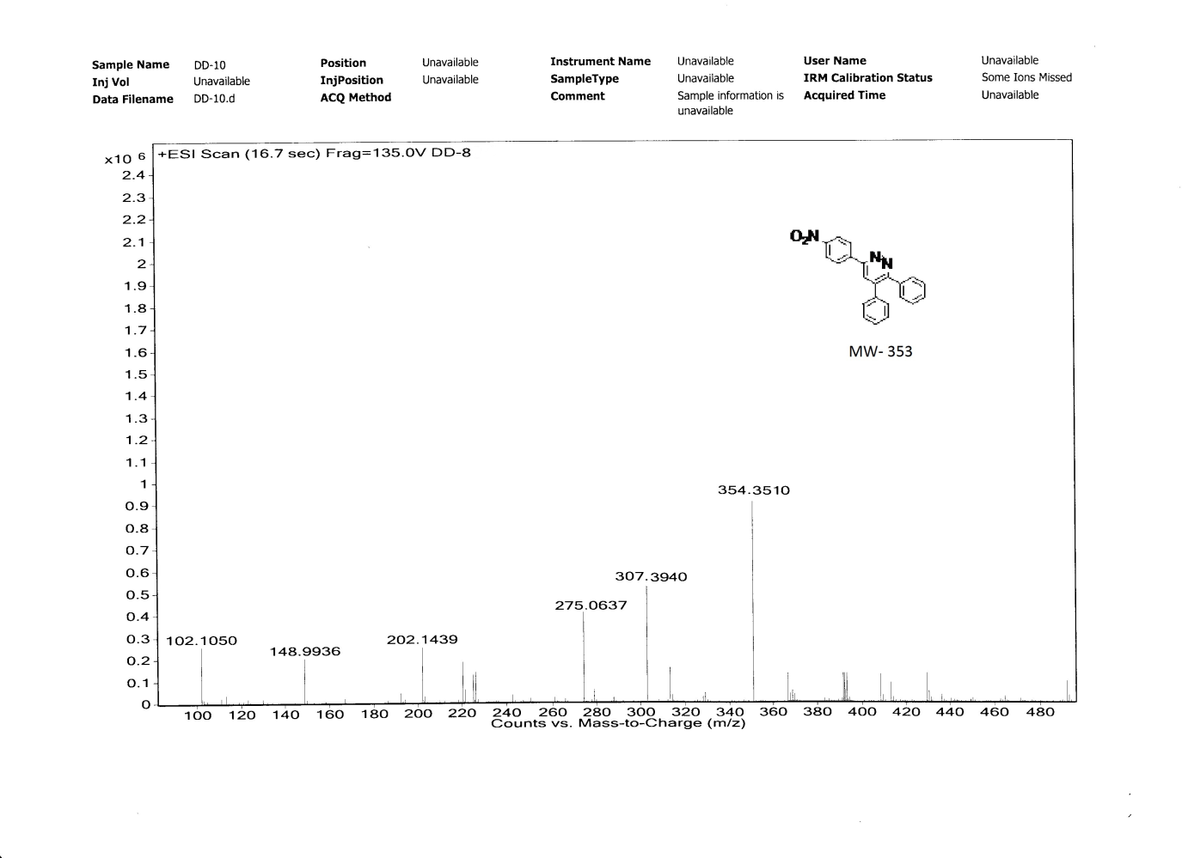

¹³CNMR spectra of entry 8 [3,4-diphenyl-6-(2,4-dihydroxyphenyl)pyridazine]

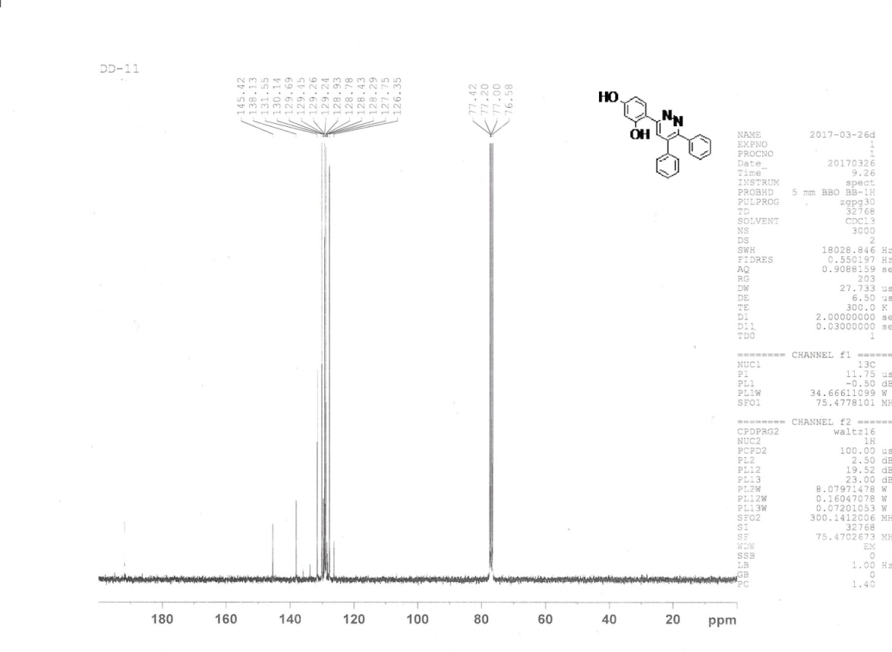

¹H NMR spectra of entry 8 [3,4-diphenyl-6-(2,4-dihydroxyphenyl)pyridazine]

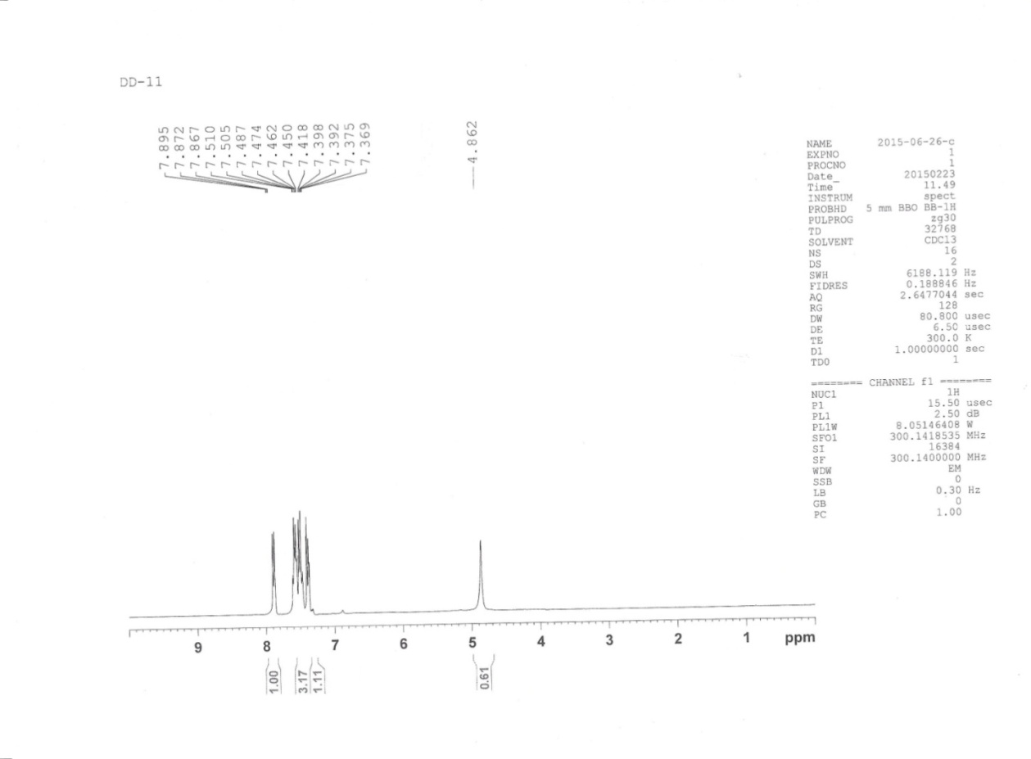

HRMS of entry 8 [3,4-diphenyl-6-(2,4-dihydroxyphenyl)pyridazine]
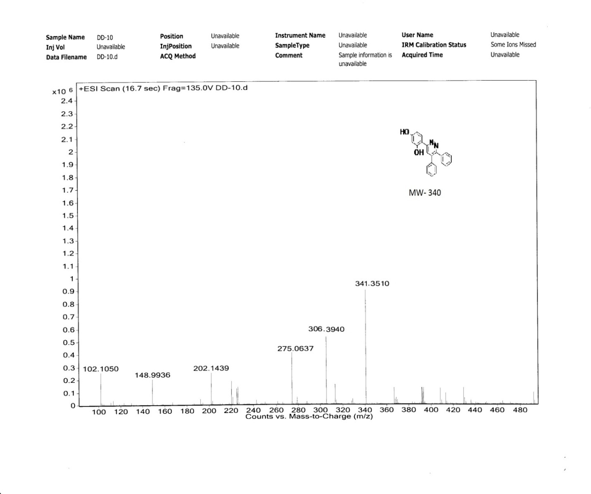

HRMS of entry 9 [3,4-diphenyl-6-(3-bromephenyl)pyridazine

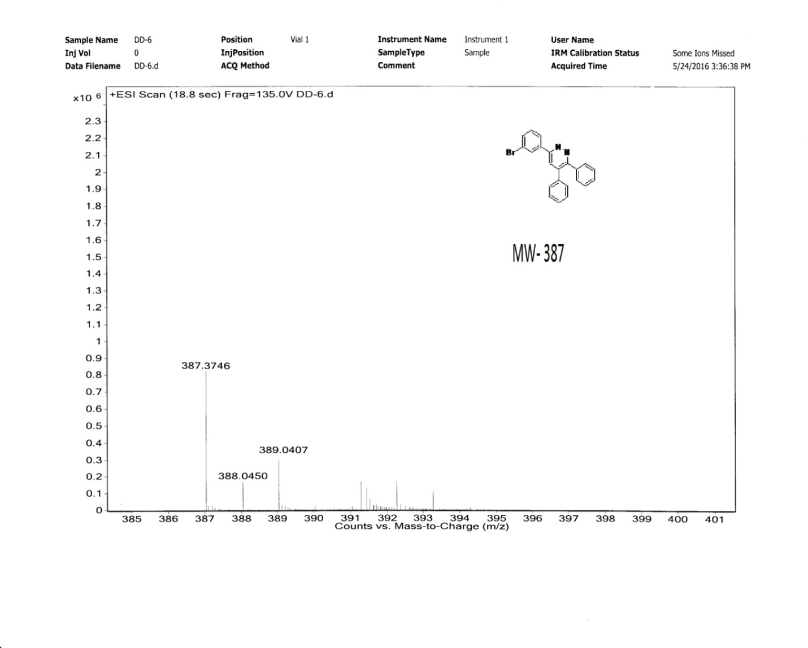

¹³C of entry 9 [3,4-diphenyl-6-(3-bromophenyl)pyridazine

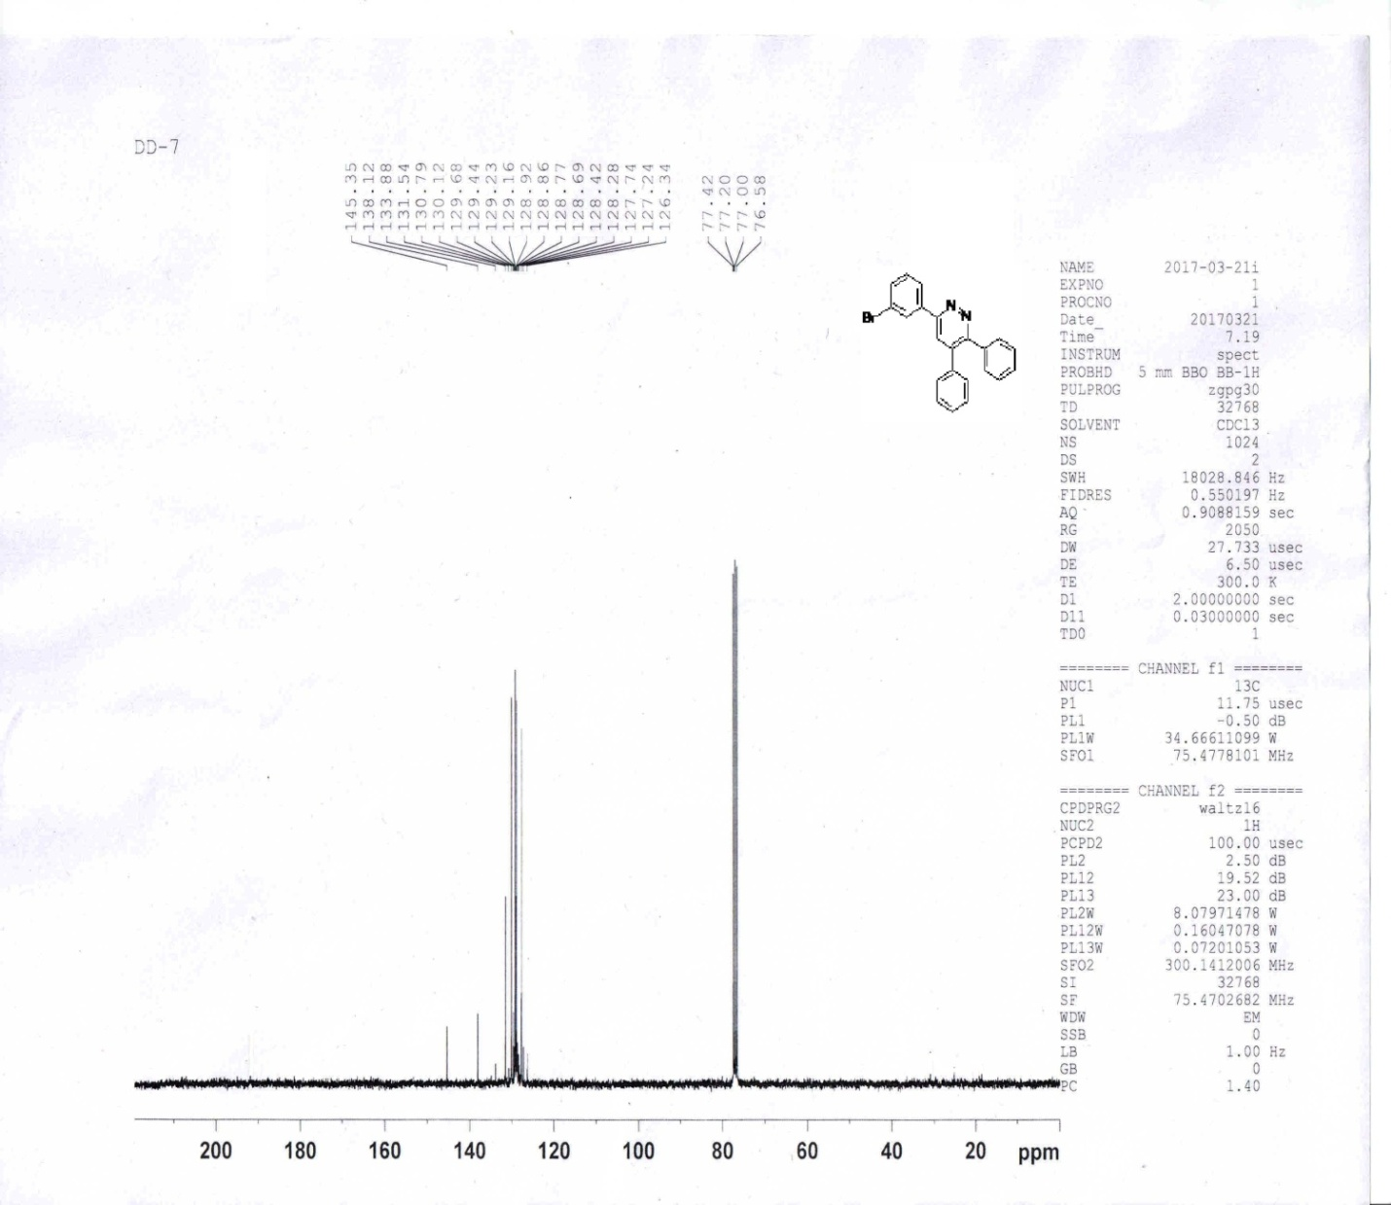

( ENTRY 9): ¹H-NMR ( 300 MHz, CDCl₃), 3,4-diphenyl-6-(3-bromophenyl)pyridazine

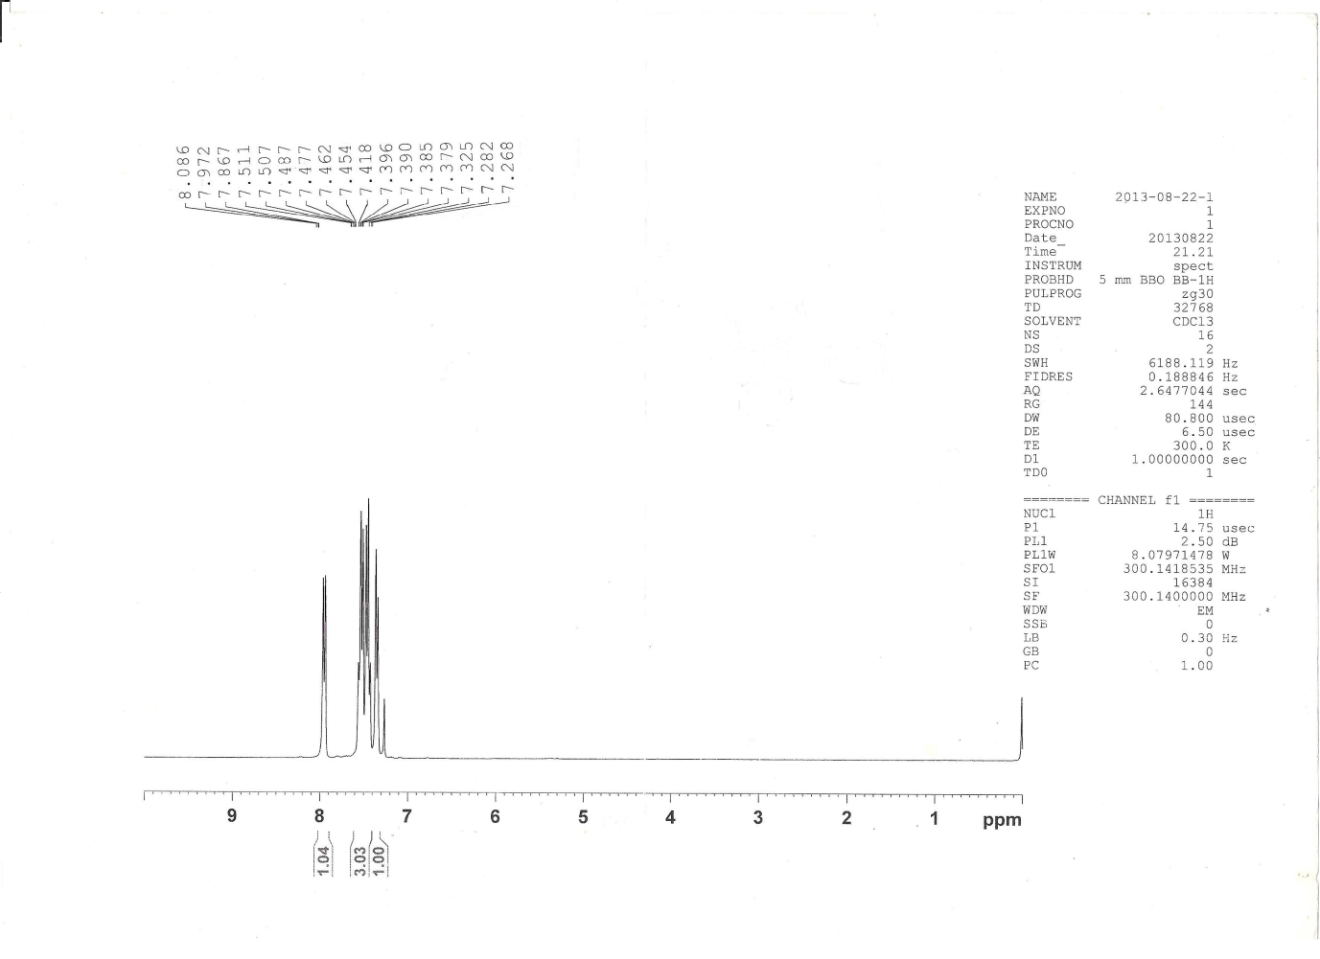

1H NMR spectra of 3,4-diphenyl-6-(2-hydroxyphenyl)pyridazine ( entry 10):
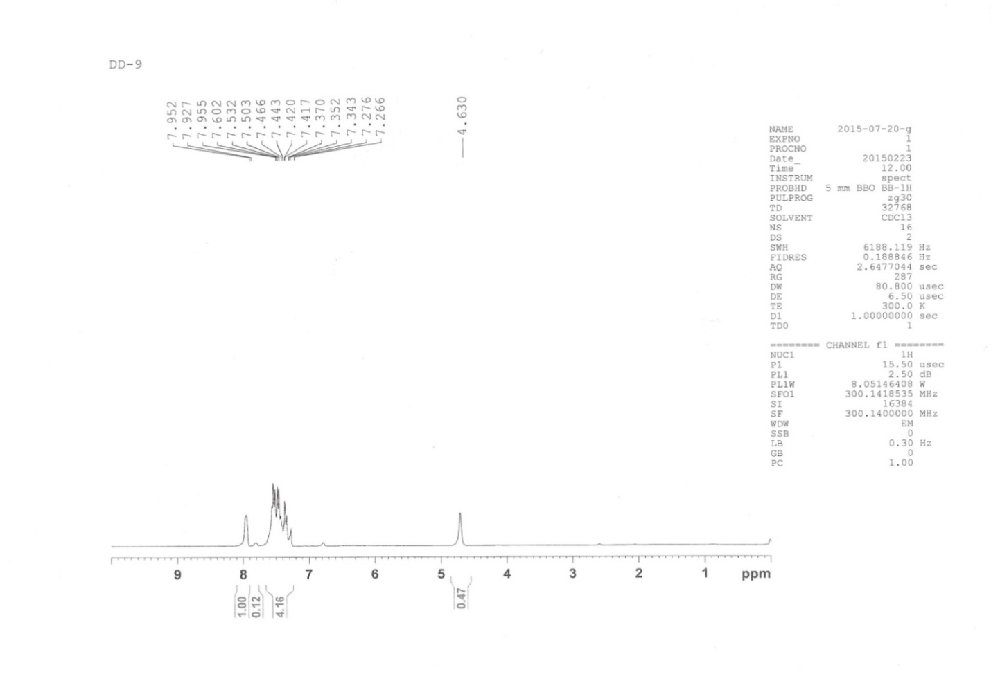

¹³C NMR ( 75 MHz, CDCl3) of 3,4-diphenyl-6-(2-hydroxyphenyl)pyridazine ( entry 10):

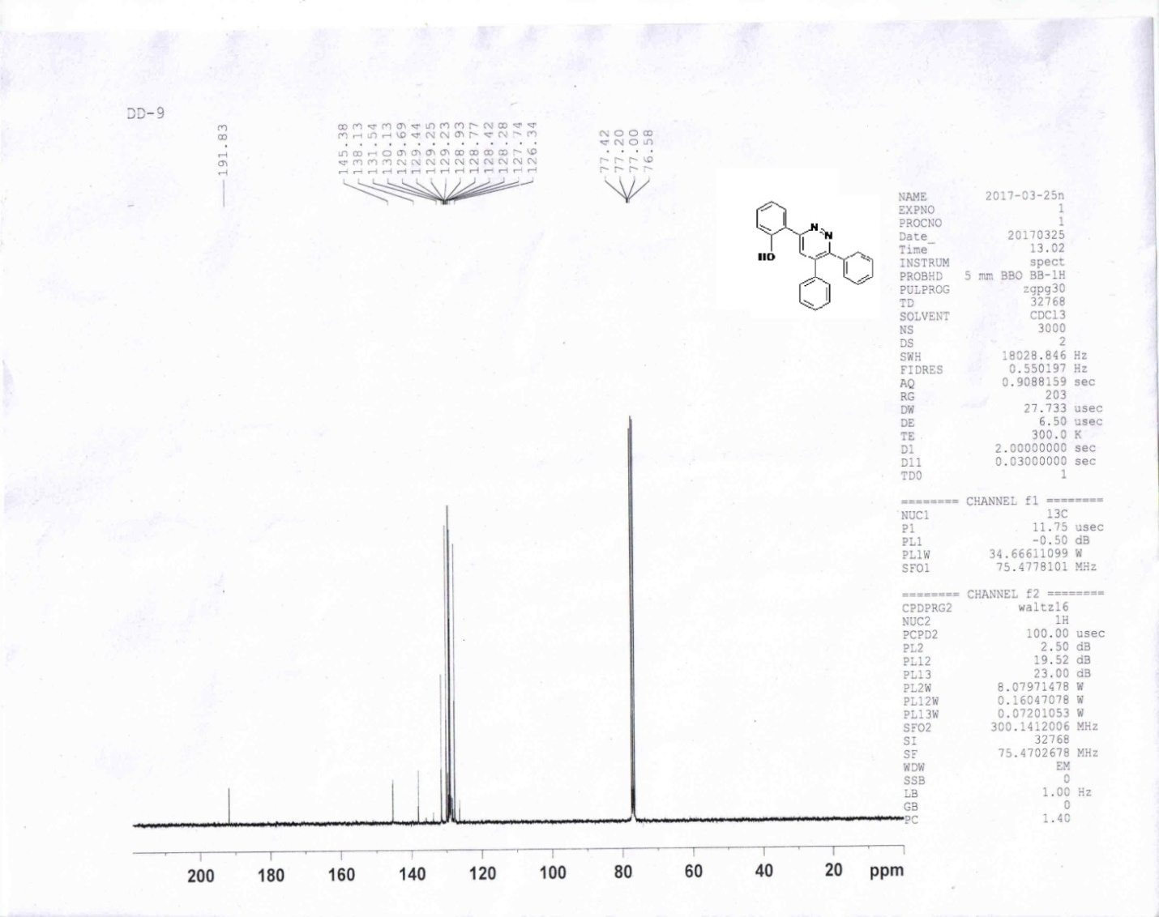

( ENTRY 10): HRMS ( M+1) 325.38 3,4-diphenyl-6-(2-hydroxyphenyl)pyridazine

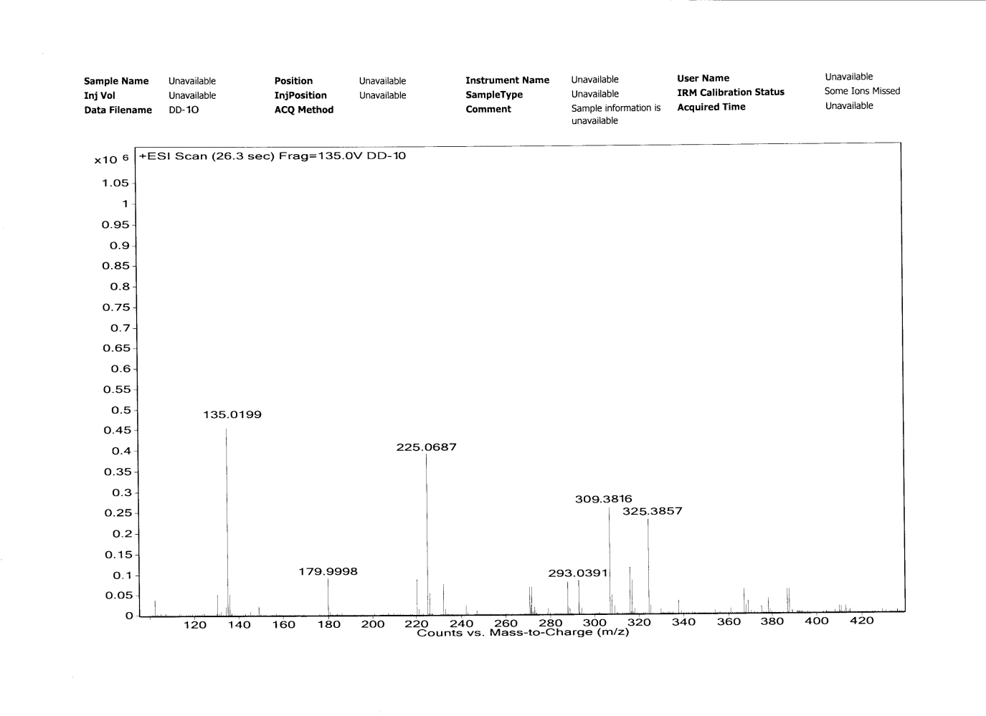

¹H NMR of [3,4-di(4-methoxyphenyl)-6-(4-methoxyphenyl)pyridazine] ( entry 11):

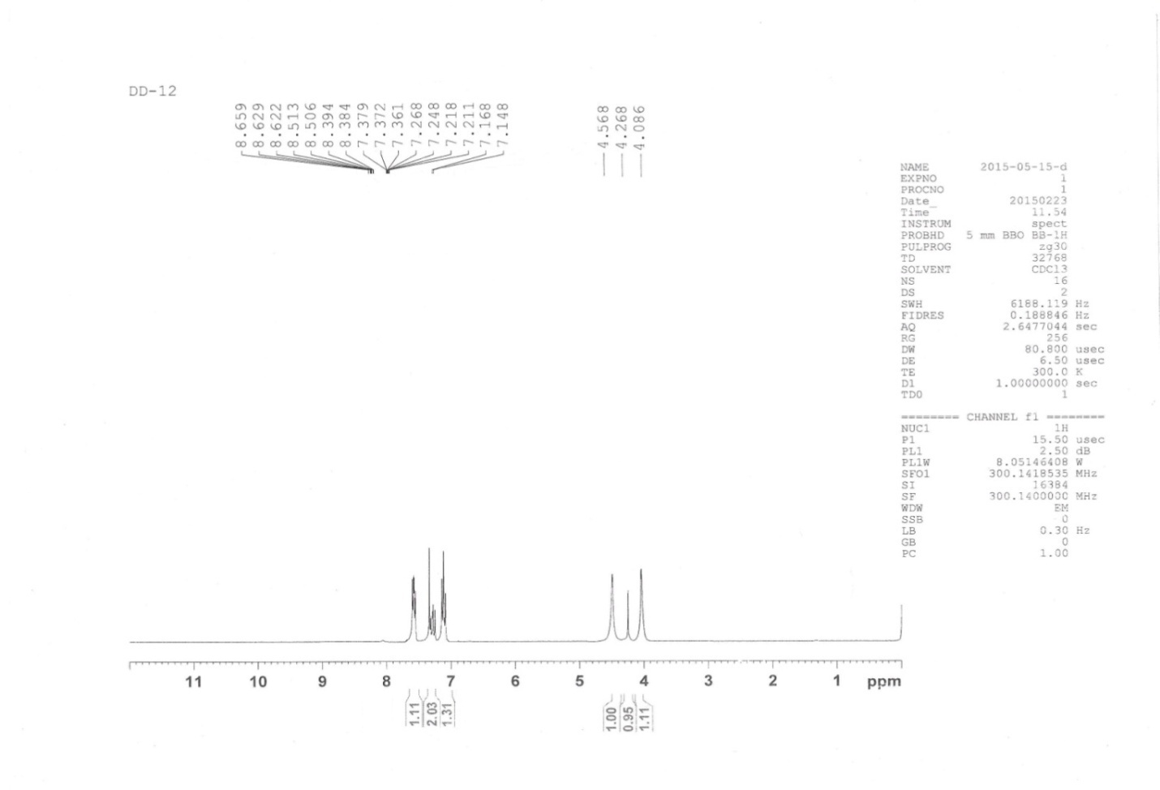

¹³C NMR of [3,4-di(4-methoxyphenyl)-6-(4-methoxyphenyl)pyridazine] ( entry 11):

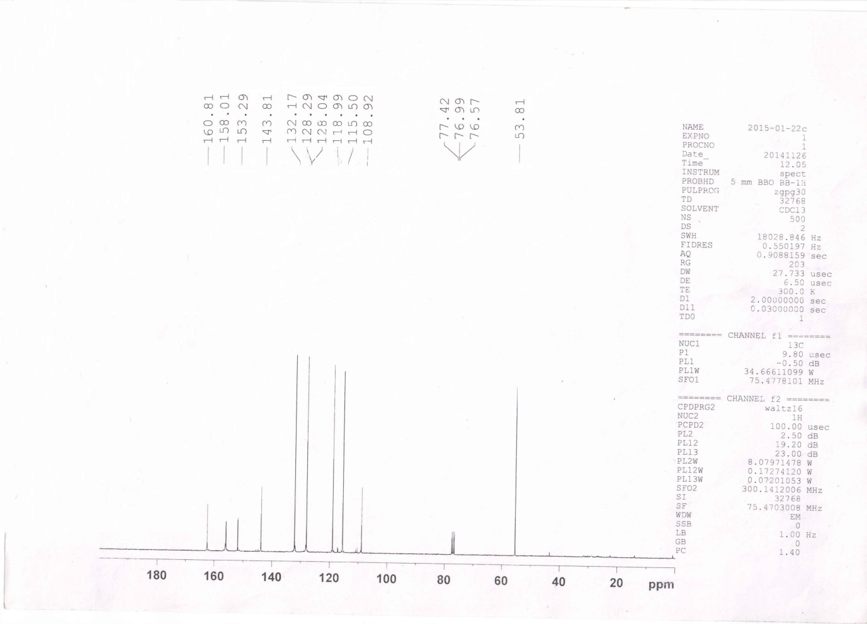

ENTRY 11: HRMS ( M+1) 3,4-di(4-methoxyphenyl)-6-(4-methoxyphenyl)pyridazine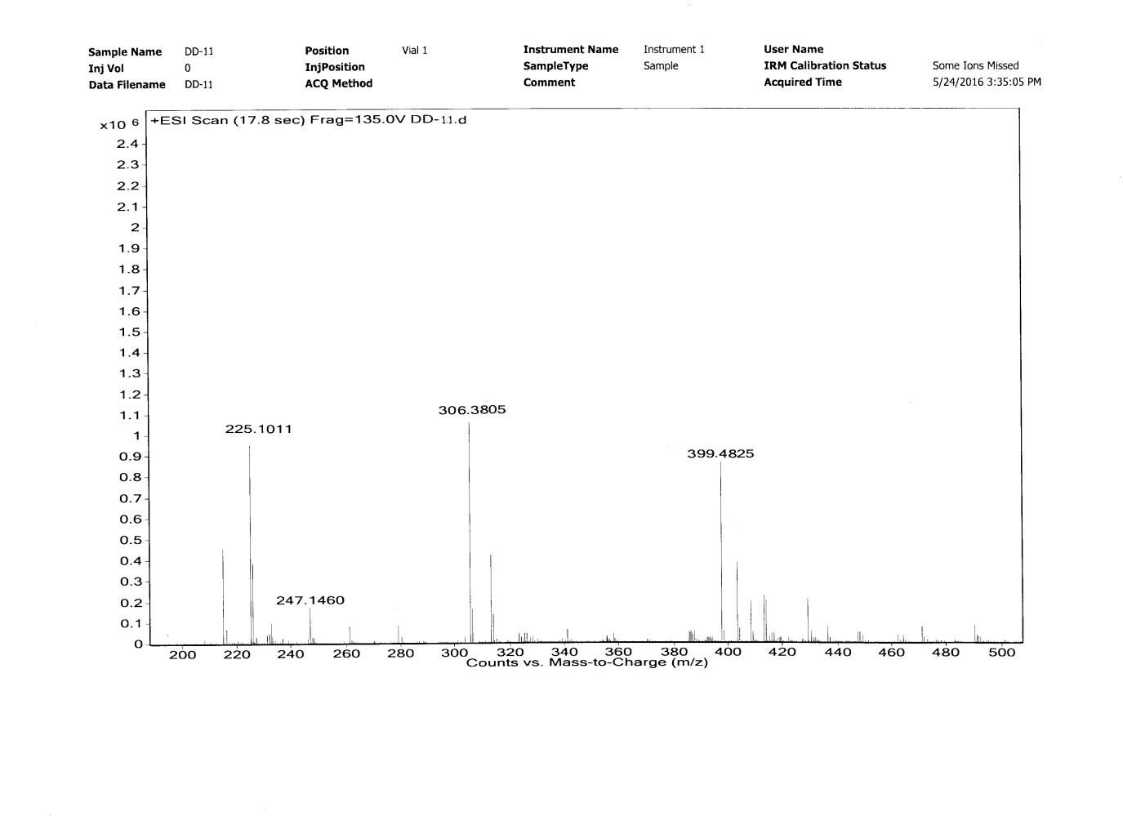

¹H NMR of ,4-di(4-methoxyphenyl)-6-(4-bromophenyl)pyridazine ( entry 12):
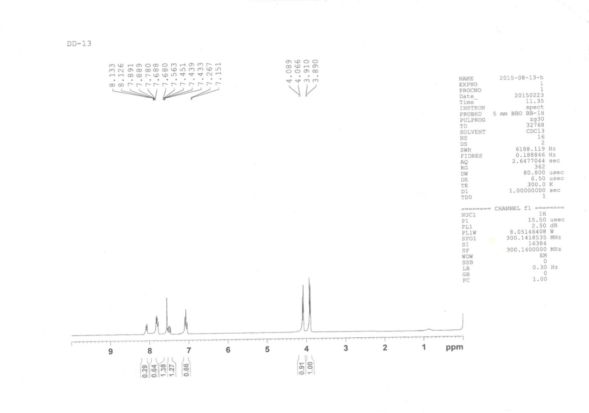

HRMS 4-di(4-methoxyphenyl)-6-(4-bromophenyl)pyridazine ( entry 12):
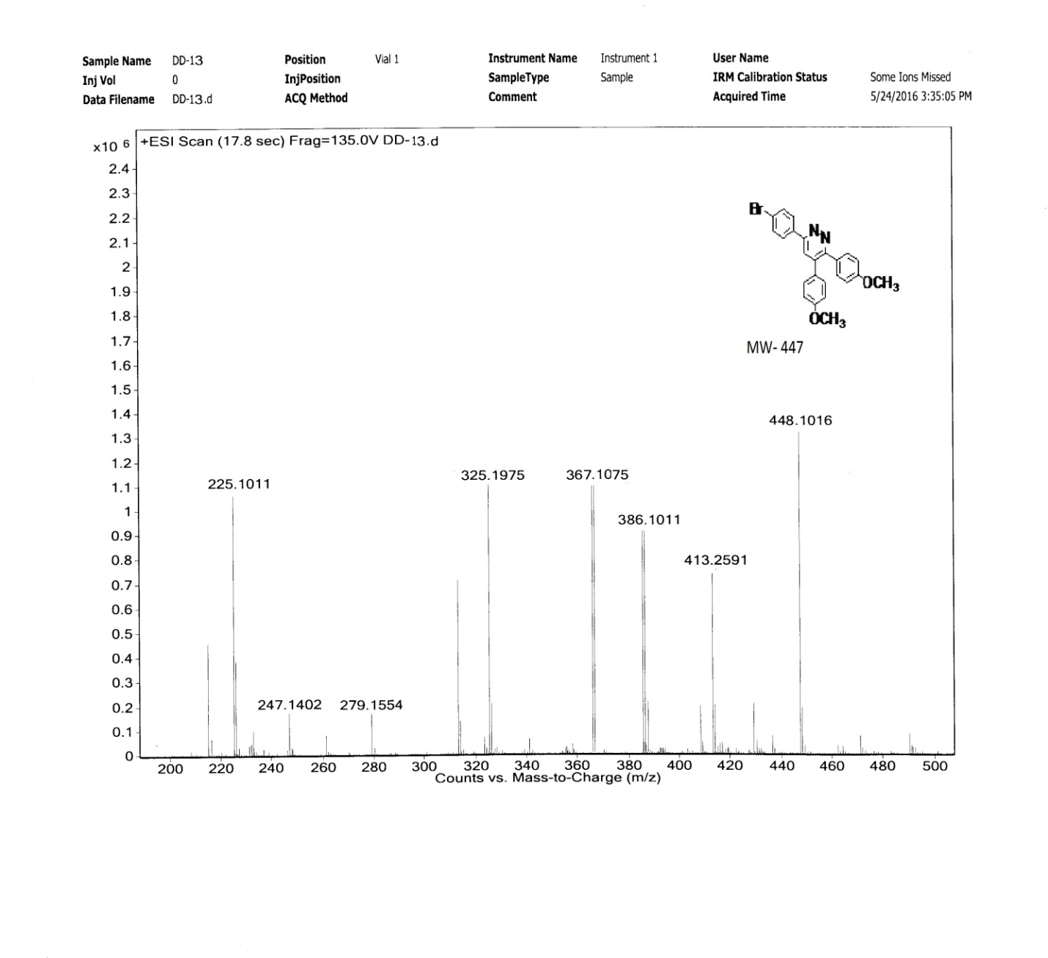

HRMS of 3,4-di( 4-methoxyphenyl)-6-(4-bromophenyl)pyridazine (entry 12)

¹H NMR spectra of 3,4-di(4- methoxyphenyl)-6-(4-chlorophenyl)pyridazine ( entry 13)

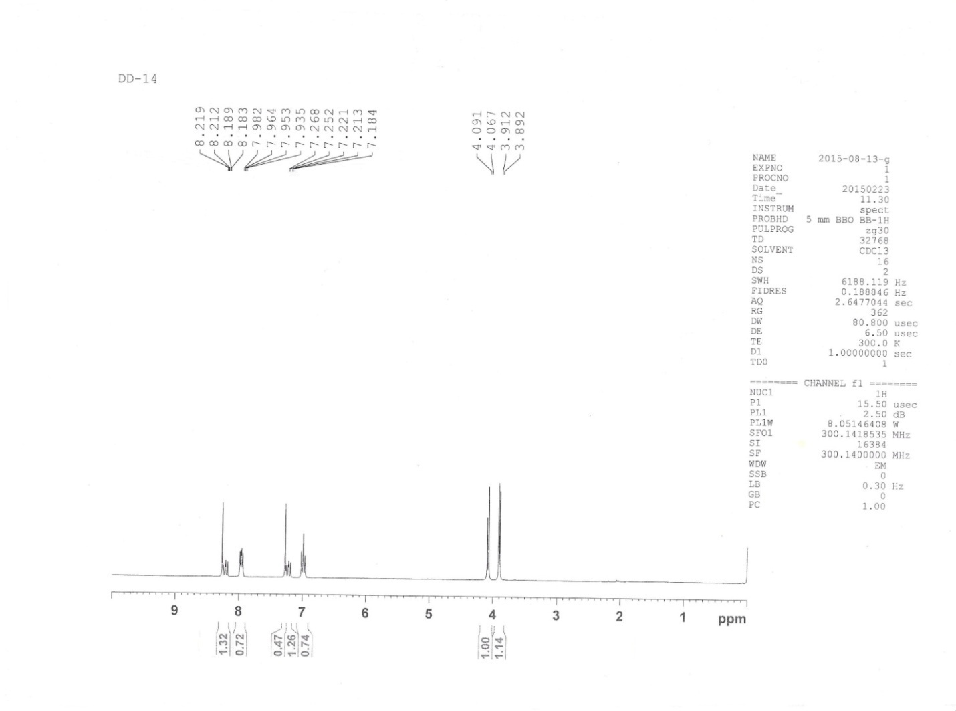

¹³C NMR spectra of 3,4-di(4- dimethoxyphenyl)-6-(4-chlorophenyl)pyridazine ( entry 13)

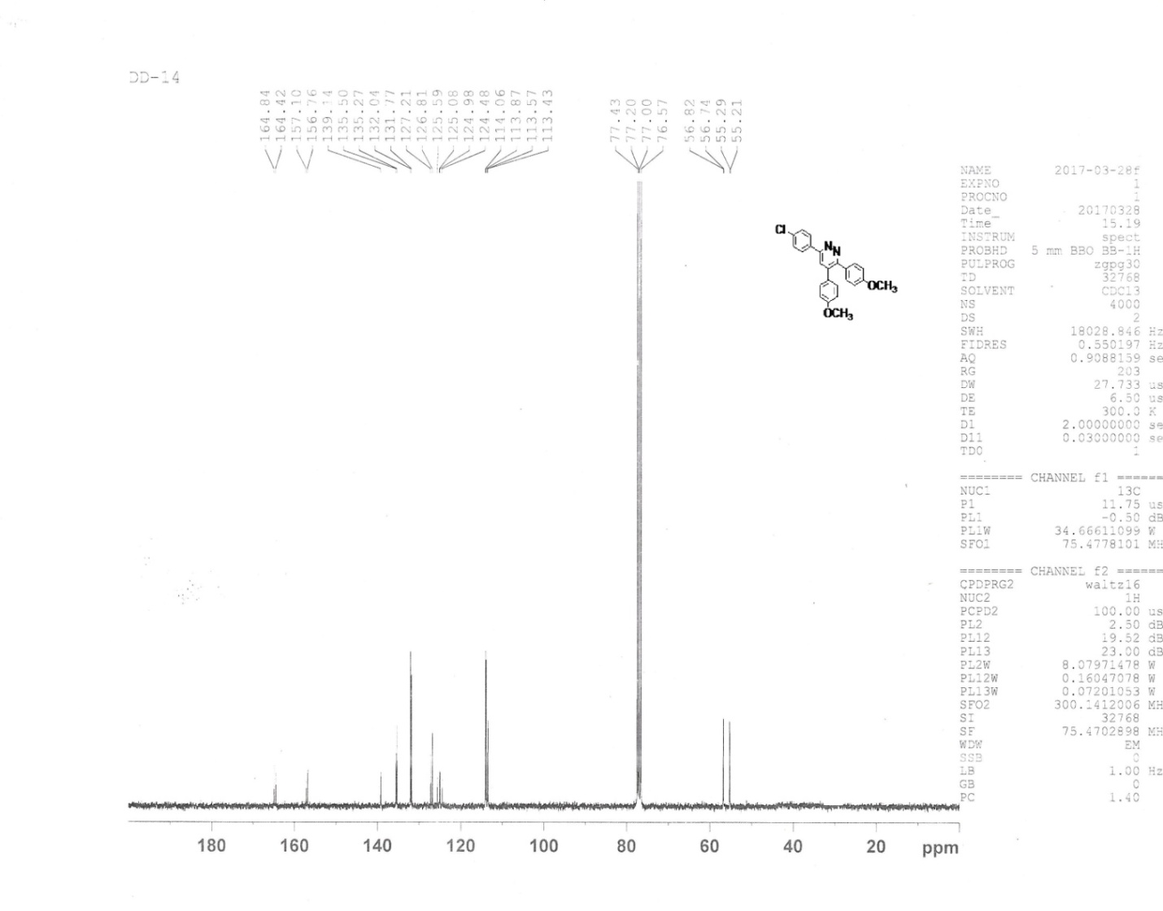

ENTRY 13: HRMS ( M+1) 3,4-di(4-methoxyphenyl)-6-(4-chlorophenyl)pyridazine
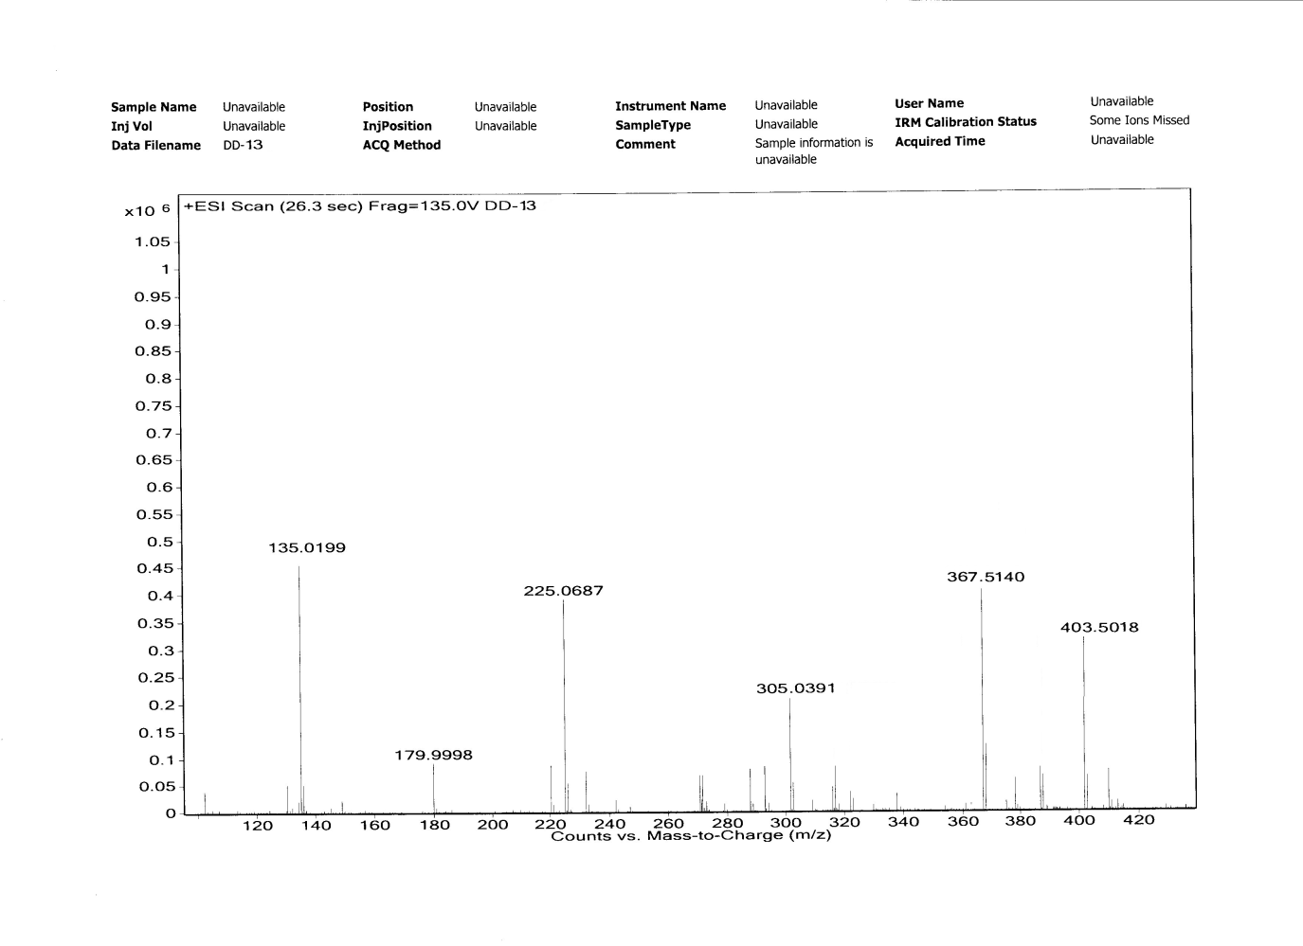

ENTRY 15: ¹H-NMR ( 300 MHz, CDCl₃, TMS):
3,4-di(4-methoxyphenyl)-6-phenylpyridazine

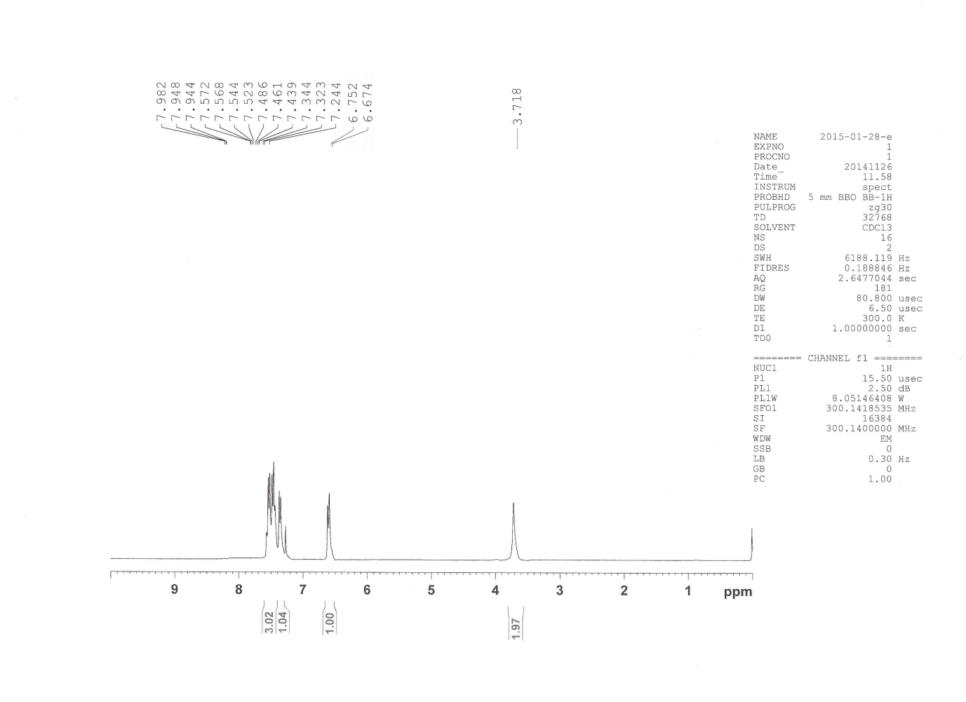

ENTRY 15: HRMS ( M+1) 3,4-di(4-methoxyphenyl)-6-phenylpyridazine

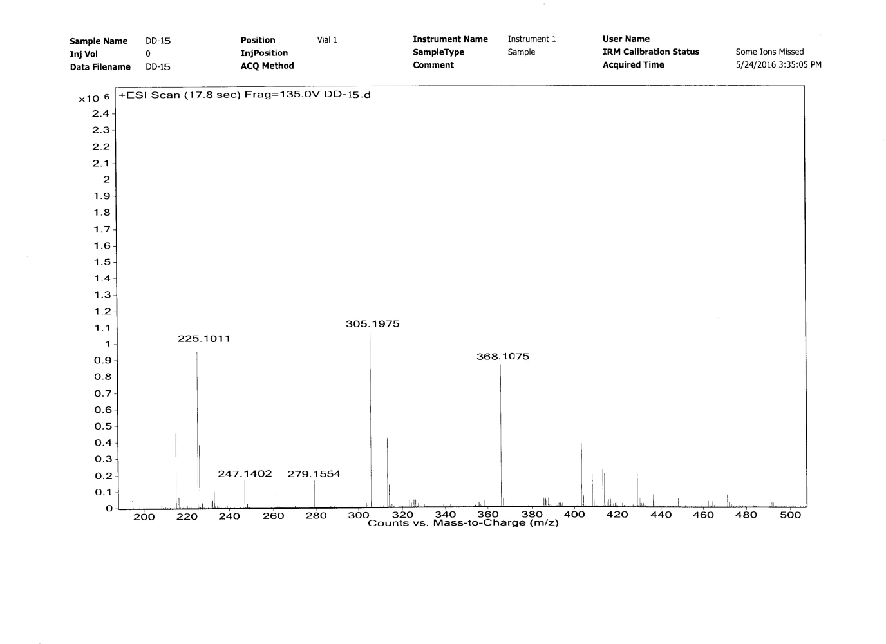

¹³C NMR of 3,4-di(4-methoxyphenyl)-6-phenylpyridazine Entry 15

