Supporting information
Highly Efficient SO₃H-Carbon Catalysed Solvent-Free Synthetic Protocol for Wax Esters Via Esterification of Long Chain Fatty Acids and Alcohols
B. L. A. Prabhavathi Devi*, K. Vijayalakshmi., T. Vijai Kumar Reddy

Department of Oils, Lipid Science & Technology CSIR- Indian Institute of Chemical Technology, Tarnaka, Uppal Road, Hyderabad - 500007, India

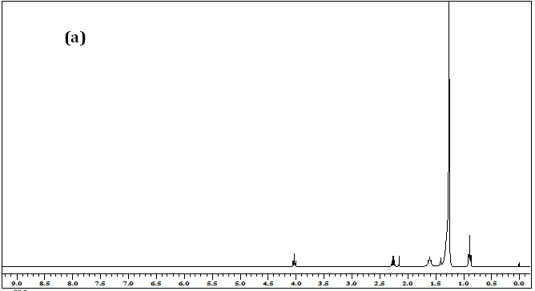

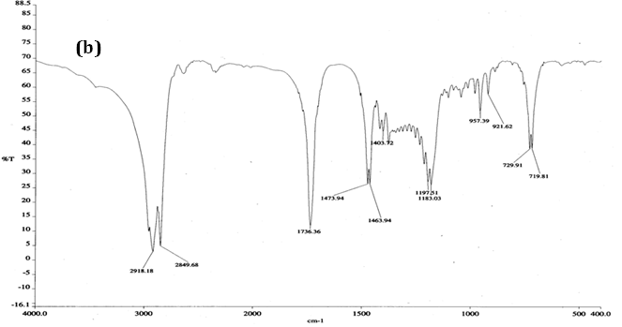
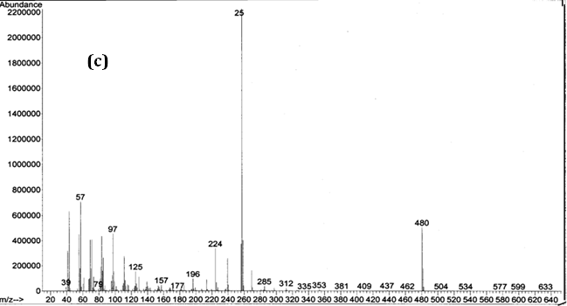
Figure S1. (a) ¹H-NMR, (b) FT-IR, and (c) GC-MS Spectra of Cetyl Palmitate (3c)

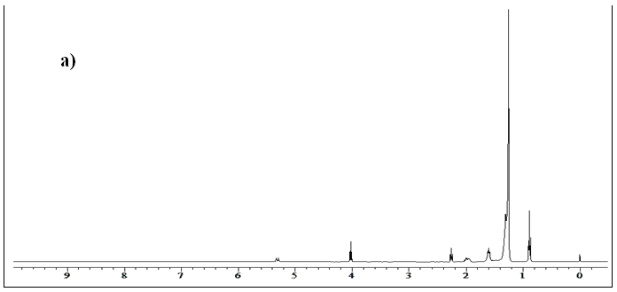
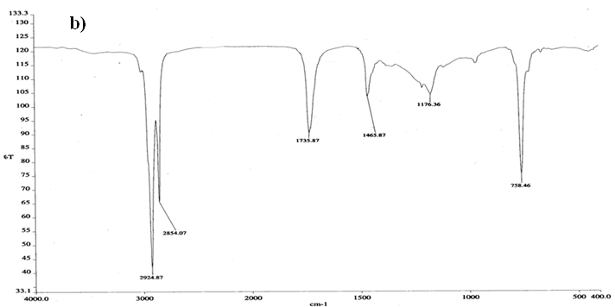
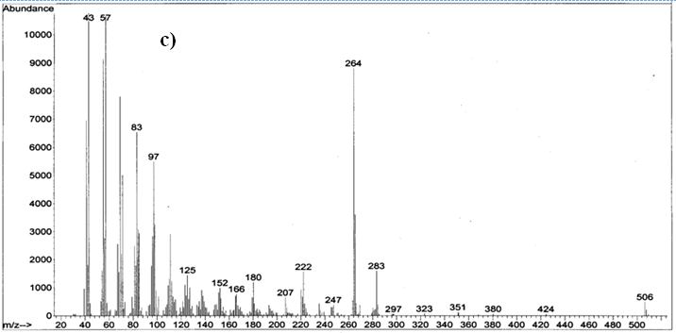
Figure S2. a) ¹H NMR, b) FT-IR and c) GC-MS Spectra of Cetyl Oleate (3e)

